Lesson 1
LO: To understand the term ‘rhetoric and the origins of rhetoric.
- What is a noun?
__________________________________________________________________
- What is a verb?
__________________________________________________________________
- What is an adjective?
__________________________________________________________________
- What is an adverb?
__________________________________________________________________
Vocabulary:
Read the following definitions and examples.
Word | Definition
credibility | Something that has credibility is believable or worthy of trust.  The speaker lost all credibility when it was revealed she had used someone else's speech
controversial | If something is controversial, it is hotly disputed or up for debate.  The prize winner turned out to be a controversial choice.
inclusive | Including something or somebody  For your homework, please answer questions 5 to 17 inclusive.  We want our school to have be an inclusive environment
manipulative | If you say someone is manipulative, you disapprove of them because they skilfully or forcefully persuade other people to do what they want them to do.  Fagin was manipulative in the way he got the boys to do his dirty work for him.
Contend | To compete for something; to assert or argue for something.  She contended for first prize.  He contended that there was too much homework

New knowledge:
Have you ever wondered how to win an argument? Have you ever wondered how to persuade someone to do what you want? Have you ever wondered how to convince someone to change their mind about something? In order to be able to do any of these things, you will need to use rhetoric.
Rhetoric is ‘the art of effective or persuasive speaking or writing.’ Rhetoric is used ALL of the time – you use it, your teachers use it, politicians use it, advertisements use it, celebrities use it.
Why might people use rhetoric?
Look at the groups of people below and consider why they might use rhetoric.
Who? | Why might this person / these people use rhetoric?
Me
My teachers
A politician
A company such as Coca Cola

New knowledge
Rhetoric originated in Athens in the second half of the 5th century BC through a group of teachers known as the Sophists. They were the first self-styled knowledge professionals who offered full intellectual training in which they claimed to be able to teach the secrets of their success. They believed that virtue could be taught, and that oration had set rules that anyone could learn. This was a challenge to the aristocracy who believed that excellence was innate.
There was an immediate backlash with Xenophon suggesting that ‘the sophists speak and write to deceive people for their own profit.’ Denouncing rhetoric as an intellectual art form, Socrates stated ‘It turns out, then, that rhetoric is an agent of the kind of persuasion which is designed to produce conviction, but not to educate people, about matters of right and wrong’ whereas he stated that ‘moral improvement rather than gratification and pleasure is always the reason for my saying anything.’
In 392 BC, Isocrates, one of the ten Attic orators and a courtroom speech writer, introduced a school of rhetoric. He disagreed with Socrates and felt that there was a connection between rhetoric and the logic of the inner mind, arguing that the arguments we use to persuade others when we speak in public, are also the arguments we employ when we deliberate in our own thoughts. Isocrates felt that there was a need for rhetorical deliberation in order to reach the best course of action.
Aristotle, an ancient Greek philosopher and scientist, also defended rhetoric. He believed that rhetoric itself was’ the faculty of observing in any given case the available means of persuasion.’ He felt that rhetoric was not simply about creating beautiful phrases, but about reading situations and seeing how elements of them could be deployed most effectively in order to win over an audience.
He believed there were three genres of rhetoric: forensic (for the courtroom), epideictic (for display – praise or blame) and deliberative (to persuade the audience to a specific course of action).
Aristotle also believed that there were three types of proof that a speech might contain: ‘The first kind depends on the personal character of the speaker; the second on putting the audience into a certain frame of mind; the third on the proof, or the apparent proof, provided by the words of the speech itself. These are the appeals to ethos (character) pathos (emotion) and logos (logic or discourse).
After Aristotle’s death, rhetorical study became an increasingly essential part of an upper class young man’s education – the linguistic culture was linked to social order and the upper classes were taught rhetorical exercises explicitly. It was also an exclusively male activity despite the technique of artful persuasion having connotations of feminine wiliness for the Romans. Orators therefore worked hard to assert their manliness through an erect posture, firm, but controlled gesture, and a tone of voice that avoided high pitches womanish screeching.

Pen to paper: Where did rhetoric originate?
Explain the significance of each of the images / people below in developing rhetoric.
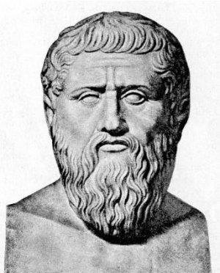
The Sophists
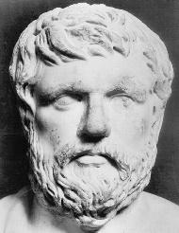
Xenophon
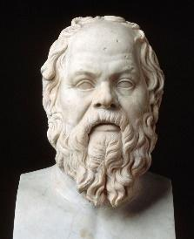
Socrates
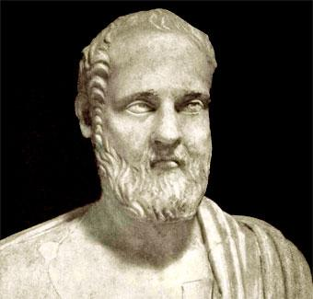
Isocrates
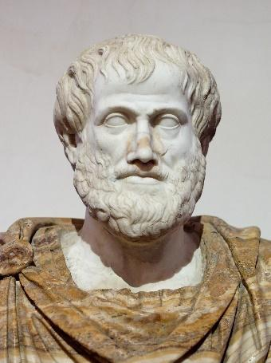
Aristotle

Reflection
What do you think?
- Do you think rhetoric can be taught?
- Is rhetoric as Xenophon suggested a means of simply
getting what you want?
- Can you be persuasive if you don’t have a logical
argument to put forward?
- Which proof do you think is the most important: logos,
ethos or pathos?
- Why do you think rhetoric was limited to upper class
men only?

___________________________________________________________________________________________________________________________________________________________________________________________________________________________________________________________________________________________________________________________________________________________________________________________________________________________________________________________________________________________________________________________________________________________________________________________________________________________________________________________________________________________________________________________________________________________________________________________________________________________________________________________________________________________________________________________________________________________________________________________________________________________________________________________________________________________________________________________________________________________________________________

Challenge: Research how rhetoric continued to develop after Aristotle’s death.

Lesson 2
LO: To understand the term ‘ethos’ and how a speaker might appeal to the audience using ethos.

Do now:
Recap questions:
- What is rhetoric?
___________________________________________________________________
- Who were the Sophists?
______________________________________________________________________________________________________________________________________
- What criticism did Xenophon raise to the Sophists?
______________________________________________________________________________________________________________________________________
- Why did Isocrates feel there was a connection between rhetoric and logic?
_________________________________________________________________________________________________________________________________________________________________________________________________________
- Aristotle argued that rhetoric went beyond beautiful language. What did he say?
______________________________________________________________________________________________________________________________________
- What are the three genres of rhetoric?
______________________________________________________________________________________________________________________________________
- What are the three proofs of rhetoric?
______________________________________________________________________________________________________________________________________
- Who was rhetoric restricted to?
___________________________________________________________________
Vocabulary:
Write the correct word alongside its definition in the table below.
Word | Definition
 | persuading other people to do what you want them to do, through force or trickery
 | to try and win something
 | when you believe in something or fully trust it
 | something that a lot of people might disagree with
 | including something or somebody

New knowledge
Last lesson we explored Aristotle’s viewpoint that there were three proofs of rhetoric: ethos, pathos and logos. In this learning episode, we are going to explore ETHOS.

An appeal to ethos is an attempt to persuade by emphasising the good character of the writer (or speaker). It is an appeal to credibility.

For example:
- Trust me, I’m a doctor.
- Buy this phone because we are the leading brand and your favourite celebrities use one too.

Ethos is the fundamental connection a speaker makes with his or her audience.
From a speaker’s point of view, utilising ethos is about the ability to convey that you are trustworthy and have credentials.
From an audience’s point of view, an appeal to ethos is needed because the audience wants to feel that you, as a speaker, are one of them; that you share their emotion; that you’re on the same team. They will want to see that you are credible, worthy of respect and of good character before they buy into your message, idea or product.
Ethos is the reason that big companies pay a lot of money for celebrities to endorse their products. The reasoning goes something like this: if our football boots are good enough for one of the best footballers in the world, then they must be good enough for you!
How do the following adverts appeal to ethos?
Watch the following two advertisements on Youtube and summarise how they appeal to ethos.
Drake Sprite: The Spark Commercial | Ethos Example  https://www.youtube.com/watch?v=SviQfBuA9c0

What methods do texts use to appeal to ethos?

Look at the following examples. For each one, consider the appeal to ethos.

In the introduction to a speech on techniques for successfully growing roses, Mary notes that she had a Ph.D. in horticulture and has been cultivating rose gardens since the time she was a child helping in her grandmother's garden.

How will this statement support her appeal to ethos?
_____________________________________________________________________
_____________________________________________________________________
_____________________________________________________________________
_____________________________________________________________________
_____________________________________________________________________

- Yesterday, you saw a fellow student and her friends leave a table overflowing with rubbish at lunchtime. As she walked away, she dropped an empty crisp packet on the floor. Today, she has been chosen to stand up in Assembly and give a speech persuading everyone to take care of the school environment.
How does what you saw yesterday affect the appeal to ethos in her speech?
____________________________________________________________________________________________
____________________________________________________________________________________________
____________________________________________________________________________________________
____________________________________________________________________________________________

- Read this review of Adele's Glastonbury performance in 2015. Then answer the question below.

Adele’s Hilarious, Heartwarming Glastonbury Headline Set
“It Was Like Watching One Of Us Up There On Stage”
Tens of thousands of people turned out to see Adele headline the Pyramid Stage at Glastonbury but she contrived to make it feel like we were huddled in a local village hall, watching someone we’ve known for years. It’s an extraordinary skill, to create a sense of intimacy at the biggest stage at the biggest festival in the world, but somehow the Tottenham singer pulled it off.
She opened, of course, with last year’s single ‘Hello’, changing the lyrics to “‘I’m in Glastonbury dreaming/Of who we used to be”. Before she performs ‘I’ll Be Waiting’, from her second album ’21’, she told us, “I might have to go straight into another one, my darlings – I don’t know what to say to you yet.” Could the most famous musician in the world right now really be overwhelmed by Worthy Farm? Well, that’s Adele’s thing, isn’t it? She’s just like one of us.
A 10-year-old girl called Lyla was invited onstage to share her festival highlights – she enjoyed Jess Glynne and Bastille, and then Adele asked if anyone in the front row had been for a poo or a wee during the show. Is it all a bit an act from a mega-famous, filthy rich A-list singer? Perhaps. But it’s impossible to deny the communal atmosphere Adele forged tonight.
The show was about recognising the commonality everyone in that field shared. And, good Lord, it must have been the biggest crowd of the weekend so far. But Adele’s force of personality seemed to vacuum-pack the entire audience. She signed off after the moving ‘Someone Like You’ by promising, “I’ll see you later!” You half-expected to bump into her drinking a beer from a can in the tent next to yours afterwards.
Jordan Bassett, New Musical Express
How does Adele connect with the Glastonbury crowd? Describe Adele's appeal to ethos during her set.
_____________________________________________________________________
_____________________________________________________________________
_____________________________________________________________________
_____________________________________________________________________
_____________________________________________________________________
____________________________________________________________________

Reflection
Think about something that you have the experience, expertise or character to talk about. It could be a particular skill, something you know about or somewhere you have lived.
Write the opening to a speech you are going to give to an audience of people who have the same thing in common with you. Write your appeal to ethos to establish your expertise, credibility or character.
_____________________________________________________________________________________________________________________________________________________________________________________________________________________________________________________________________________________________________________________________________________________________________________________________________________________________________________________________________________________
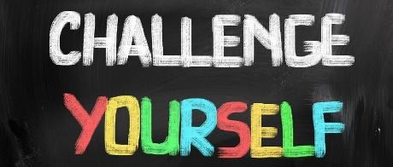
Find your own text – advert, speech, newspaper article – that appeals to ethos. Explain how it does so below.
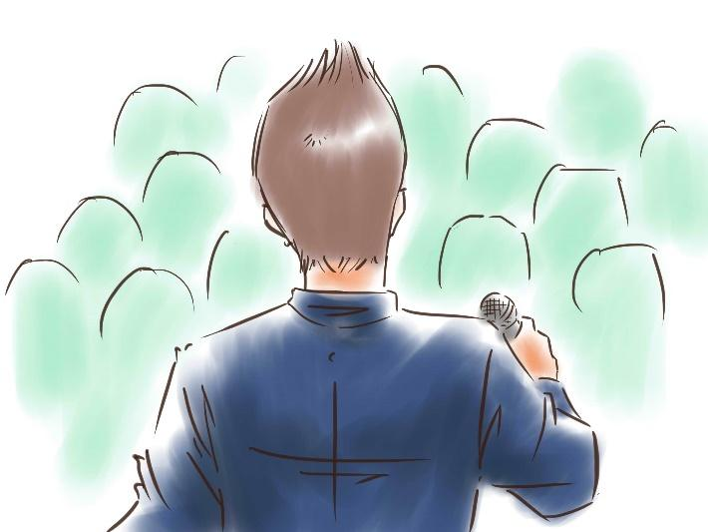

Lesson 3

LO: To understand the term ‘logos’ and how a speaker might appeal to the audience using ‘logos’

Do now
- What is ethos?
_________________________________________________________________
- Which of the following statements is an example of ethos?
A. He couldn’t have been there last night; he was seen at work at 10 pm.
B. Trust me, I’ve been a forensic investigator for ten years and my judgment has never been wrong.
C. He’s a dangerous man and if you let him walk free your child could be next.

_______________________________________________________________________________________________
- Why is an appeal to ethos important for a speaker?
______________________________________________________________________________________________________________________________________
- Why is an appeal to ethos important for the audience?
______________________________________________________________________________________________________________________________________
- Why might celebrities be use an appeal to ethos?
______________________________________________________________________________________________________________________________________
Vocabulary:
Identify which of the two options would be a correct use of each word. Place a tick alongside your choice.
Word |  | Definition
credibility |  | a person with a lot of qualifications in a subject
 |  | an anonymous report on twitter
controversial |  | a new advert receives many complaints for sexism
 |  | someone complaining in a restaurant that their meal was not hot
inclusive |  | a school where only students from a particular religion are allowed to attend
 |  | a school where pupils are welcomed from many different religions
manipulative |  | someone gives you a small gift before asking to borrow some money
 |  | someone buys you lunch because your Parent Pay account isn’t working
contend |  | someone argues that today’s children face more stress than their parents did
 |  | someone argues with someone else for pushing into the dinner queue

New knowledge
In the last learning episode, we were exploring how speakers appeal to ethos. In this learning episode we are exploring how speakers appeal to LOGOS.
An appeal to logos is an attempt to persuade by sounding reasonable and logical. It is an appeal to logic.

For example:
- Buy this phone because it has better signal and more memory than your current phone.

Aristotle placed a high importance on using logic to try and persuade people to do something. This makes sense: if you are able to explain to people why doing one thing will lead to another, or why a certain course of action is reasonable, then if they are sensible, reasonable people, it should appeal to them.
Logos is a way of arguing calmly and carefully, using reason alone and not relying on emotion. Logos is a Greek word meaning “reason” or “rationality.”
This advert for a new toothbrush carefully explains why it works better than other toothbrushes:
This government advert gives clear reasons to persuade people it is a good idea to stop smoking:
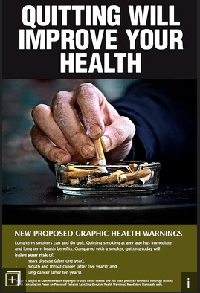
To make an appeal to logos, think about the following:
- Give reasons! Whenever you make a logical statement, you have to back it up with evidence.
- Avoid getting emotional. When you write a paper, you’re probably tempted to write about subjects you feel passionate about. But this isn’t always the best idea! If you’re too passionate about the subject, you won’t be able to look past your own emotional perspectives, and that will make your paper less logical.
- Think about counter-arguments in advance. If you can master this skill, you’ll be an expert at persuasion. Think carefully about what someone else might say against your argument. What is the strongest possible case you can make against yourself? If you can come up with good counter-arguments and respond to them logically, your argument will be irresistible.
Task
Find an advert that appeals to logos and stick it on this page. Identify how it successfully appeals to logos and why this might help influence readers.

How does your chosen advert appeal to logos? How might it influence a reader?
_______________________________________________________________________________________________________________________________________________________________________________________________________________________________________________________________________________________________________________________________________________
Lesson 4
LO: To understand the term ‘pathos’ and how a text might appeal to an audience using ‘pathos’
To develop my understanding further I need to take the following steps:
Define the term ‘pathos’ and explain what it means to appeal to ‘pathos’
Explain the methods a range of texts use to appeal to pathos.
Explain why it is important that speakers and texts appeal to pathos.

Do now task
Recap questions:
- What is an appeal to logos?
___________________________________________________________________
- Which of the following statements is an example of logos?
A. We must pass this law or else all of the starving countries in this nation will die.
B. Homelessness amongst children has risen 25% in this country in the past decade.
C. As a social worker, I can tell you from my direct experience that things have got worse for children in this country.
___________________________________________________________________________
- Why is an appeal to logos important for the audience?
______________________________________________________________________________________________________________________________________
- If you are appealing to logos, what should you avoid?
______________________________________________________________________________________________________________________________________
- If you are appealing to logos, what should you consider beforehand?
______________________________________________________________________________________________________________________________________
New knowledge
Over the last two learning episodes we have looked at how speakers can appeal to ethos and logos. In this learning episode, we are going to explore how speakers can appeal to PATHOS.
An appeal to pathos is an attempt to persuade by using emotion. It is an appeal to emotion.

For example:
- Buy my phone so that I can afford to take my cute kitten to the vet and pay for some life-saving treatment!
- You will never be happy in life if you do not seize this opportunity!

Learning how to use pathos just might save your life! If you have credibility as a speaker (or writer) and have explained your case well, then it doesn’t hurt to get a little bit emotional as well. This doesn’t mean that you need to shed a tear – although sometimes that can be an effective tactic! – but you need to use your words to get your audience feeling.
We might say that logos comes from the mind, while pathos comes from the heart.
To make an appeal to pathos, consider the following:
- Do your words evoke feelings?
- Do your visuals evoke emotional responses?
- Emotional connection can be created in many ways by a speaker, perhaps most notably by stories. The goal of a story, anecdote, analogy and metaphor is often to link an aspect of our core message with a triggered emotional response from the audience.

What methods are used in print advertising to appeal to pathos?
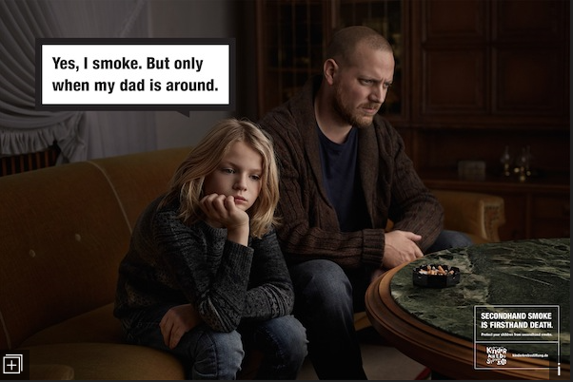
Pathos is used a lot in advertising. Look at the following images and answer the questions that follow.

How does this advert make an appeal to pathos?
_________________________________________________________________________________________________________________________________________________________________________________________________________
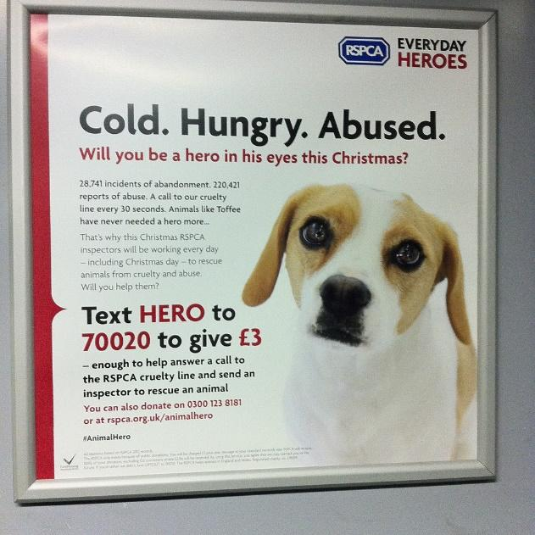
How does this advert make an appeal to pathos?
_________________________________________________________________________________________________________________________________________________________________________________________________________

What methods do televised advertisements use to appeal to pathos?
Now we will watch an advert for the bank, Nationwide (On your side for generations https://www.youtube.com/watch?v=6rTgukt4KWU) which is in the form of the story. The bank hopes that by watching the advert you will be persuaded to give your money to them. As you watch, note down all the parts of the story you think have been written as an appeal to pathos: designed to make you react emotionally.
Appeal to pathos – What emotion does the advert want you to feel? | How does it work to appeal to pathos? What happens in the advert to provoke that emotion?
What are Nationwide hoping to achieve by appealing to pathos in this advertisement?

Reflection
Pathos is important in politics too.
In 2017, there was a General Election in the UK. Prime Minister Theresa May called the election and was expected to do very well. However, in the end her party did not win enough seats to form a government on their own. Some commentators have analysed the Prime Minister’s rhetoric to see why she was unable to persuade more people to vote for her.
Something missing in Theresa May’s speeches
Looking back at her speeches, today and throughout the campaign, there is a sense that something was missing. People have focused on her “cracking” voice in her acceptance speech in her constituency. Her voice wobbles during her interview with Andrew Neill were clear. But I think the problem was more fundamental.
When talking about persuasion or rhetoric it is not long before you get back to Aristotle. He set out Logos, Pathos and Ethos as three modes of persuasion. We often encourage clients to use a balance of these three based on the needs of the people you are trying to persuade.
What Aristotle can teach us about persuasion
To keep things simple, let’s think of Logos, Pathos and Ethos as being Logic, Emotion and Credibility. Looking through Theresa May’s speeches she champions Credibility at every opportunity: strong and stable leadership, safety, security and certainty are her favourite terms.
Logic is light. She tends not to spend a lot of time giving out reasoned arguments but at least it gets some air time.
Emotion is the area that is pretty much completely missing. At no point during her acceptance speech or on the steps of Downing Street does Theresa May acknowledge the disappointment of the night’s results. Whatever your political preferences it is clear it was an awful outcome compared to expectations for her and for her party. By not even mentioning her feelings about this, the speech can seem remote or out of touch.
Sometimes you really do need to show some emotion
Looking back through the campaign, Pathos or emotion was consistently missing. I am not suggesting this is the reason for the result last night. It could be one factor behind the Prime Minister’s falling approval ratings. It is hard to warm to someone who shows no emotion. What I am suggesting is that when people know you must be hurting, failure to acknowledge any emotion makes a speech sound false. This could be what destroys the credibility that has been the basis of so much of her campaign.

In your own words, describe what the writer is saying is ineffective about the Prime Minister's speeches after the 2017 election.
_________________________________________________________________
_________________________________________________________________
_________________________________________________________________
_________________________________________________________________
_________________________________________________________________
_________________________________________________________________
_________________________________________________________________
_________________________________________________________________
_________________________________________________________________
_________________________________________________________________
_________________________________________________________________

Lesson 5
LO: To be able to explain who Martin Luther King was and why he is such a significant historical figure.
Do now - Use your knowledge organiser to answer the following questions:

- What were the Jim Crow laws in the USA? ______________________________________________________________
________________________________________________________________________________________________________________________________________________________________________________________________________________________________________________________________________________________________________________________________________________________________________________________________________________________________________________________________________________________________________________________________.
- Who were the Windrush generation?
___________________________________________________________________________________________________________________________________________________________________________________________________________________________________________________________________________________________________________________________________________________________________________________________________________________________________________________________________________________________________________________________________________________________________________________________________________________________
What do we already know about our next rhetorician?
On the next page, there is an image of the man who gave our next speech. Before we look at his speech in detail, what do you already know about him? Thought shower your knowledge around their images.

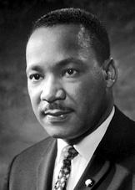

New knowledge: Who was Martin Luther King?
The man above is Martin Luther King and you have already identified some of the things you have previously learnt about him. Below is a summary of his life taken from The Nobel Prize website.
1 | Martin Luther King Jr, (January 15, 1929 - April 4, 1968) was born
2 | Michael Luther King Jr, but later had his name changed to Martin.
3 | His grandfather began the family’s long tenure as pastors of the
4 | Ebenzer Baptist Church in Atlanta, serving from 1914 to 1931; his
5 | father has served from then until the present, and from 1960 until
6 | his death Martin Luther acted as co-pastor. Martin Luther attended
7 | segregated public schools in Georgia, graduating from high school
8 | at the age of fifteen; he received the BA degree in 1940 from
9 | Morehouse College, a distinguished Negro institution of Atlanta from
10 | which both his father and grandfather had graduated. After three
11 | years of theological study at Crozer Theological Seminary in
12 | Pennsylvania where he was elected president of a predominantly
13 | white senior class, he was awarded the BD in 1951. With a
14 | fellowship won at Crozer, he enrolled in graduate studies at Boston
15 | University, completing his residence for the doctorate in 1953 and
16 | receiving the degree in 1955. In Boston he met and married Coretta
17 | Scott, a young woman of uncommon intellectual and artistic
18 | attainments. Two sons and two daughters were born into the family.
19 | In 1954, Martin Luther King became pastor of the Dexter Avenue
20 | Baptist Church in Montgomery, Alabama. Always a strong worker
21 | for civil rights for members of his race, King was, by this time, a
22 | member of the executive committee of the National Association for
23 | the Advancement of Coloured People, the leading organisation of
24 | its kind in the nation. He was ready, then, early in December 1955,
25 | to accept the leadership of the first great Negro nonviolent
26 | demonstration of contemporary times in the United States, the bus
27 | boycott described by Gunnar Jahn in his presentation speech in
28 | honour of the laureate. The boycott lasted 382 days. On December
29 | 21, 1956, after the Supreme Court of the United States had declared
30 | unconstitutional the laws requiring segregation on buses, Negroes
31 | and whites rode the buses as equals. During these days of boycott,
32 | King was arrested, his home was bombed, he was subjected to
33 | personal abuse, but at the same time he emerged as a Negro
34 | leader of the first rank.
35 | In 1957 he was elected president of the Southern Christian
36 | Leadership Conference, an organisation formed to provide new
37 | leadership for the now burgeoning civil rights movements. The
38 | ideals for this organisation he took from Christianity; its operational
39 | techniques from Gandhi. In the eleven-year period between 1957
40 | and 1968, King travelled over six million miles and spoke over
41 | twenty-five hundred times, appearing wherever there was injustice,
42 | protest, and action; and meanwhile he wrote five books as well
43 | as numerous articles. In these years, he led a massive protest in
44 | Birmingham, Alabama, that caught the attention of the entire world,
45 | providing what he called a coalition of conscience, and inspiring his
46 | “Letter from Birmingham Jail”, a manifesto of the Negro revolution;
47 | he planned the drives in Alabama for the registration of Negroes as
48 | voters; he directed the peaceful march on Washington D.C. of
49 | 260,000 people to whom he delivered his address: “I Have a Dream”,
50 | he conferred with President John F Kennedy and campaigned for
51 | Lyndon B. Johnson; he was arrested upwards of twenty times and
52 | assaulted at least four times; he was awarded five honorary
53 | degrees; was named Man of the Year by Time magazine in 1963;
54 | and became not only the symbolic leader of American blacks but
55 | also a world figure.
56 | At the age of thirty-five, Martin Luther King Jr, was the youngest man
57 | to have received the Nobel Peace Prize. When notified of his
58 | selection, he announced that he would turn over the prize money of
59 | $54,123 to the furtherance of the civil rights movement.
60 | On the evening of April 4, 1968, while standing on the balcony of
61 | his motel room in Memphis, Tennessee, where he was to lead a
62 | protest march in sympathy with striking garbage workers of that city
63 | he was assassinated.

Who was Martin Luther King and what have I learnt about him?
- Who was Martin Luther King?
_______________________________________________________________________________________________________________________________________________________________________________________________________________________________________________________________________________________________________________________________________________
- Go back to your initial thought shower and, using your purple pen, add at least five things you have learnt about Martin Luther King from your reading.

What was the purpose of the ‘I Have a Dream’ speech?
We are now going to read and listen to Martin Luther King give his infamous ‘I Have a Dream’ speech. We are going to be active readers though! As we are reading,
- Identify the purpose of this speech. Why has Martin Luther King given this speech? What does he hope to achieve by making it?
_______________________________________________________________________________________________________________________________________________________________________________________________________________________________________________________________________________________________________________________________________________
- How does Martin Luther King appeal to ethos, pathos and logos? (As we are reading, identify in the margin where you think he appeals to ethos, pathos and logos).

Martin Luther King, Jr - I Have a Dream.
1 | I am happy to join with you today in what will go down in history
2 | as the greatest demonstration for freedom in the history of our
3 | nation.
4 | Five score years ago, a great American, in whose symbolic
5 | shadow we stand today, signed the Emancipation Proclamation.
6 | This momentous decree came as a great beacon light of hope to
7 | millions of Negro slaves who had been seared in the flames of
8 | withering injustice. It came as a joyous daybreak to end the
9 | long night of their captivity.
10 | But one hundred years later, the Negro is still not free. One
11 | hundred years later, the life of the Negro is still sadly crippled
12 | by the manacles of segregation and the chains of
13 | discrimination. One hundred years later, the Negro lives on a
14 | lonely island of poverty in the midst of a vast ocean of material
15 | prosperity. One hundred years later, the Negro is still
16 | languished in the corners Of American society and finds
17 | himself an exile in his own land. And so we’ve come here today
18 | to dramatize a shameful condition.
19 | In a sense we’ve come to our nation’s capital to cash a check.
20 | When the architects of our republic wrote the magnificent words
21 | of the Constitution and the Declaration of Independence, they
22 | were signing a promissory note to which every American was
23 | to fall heir. Their note was a promise that all men, yes, black
24 | men as well as white men, would be guaranteed the
25 | “unalienable Rights” of “Life, Liberty and the pursuit of
26 | happiness.” It is obvious today that America has defaulted on
27 | this promissory note, insofar as her citizens of colour are
28 | concerned. Instead of honouring this sacred obligation,
29 | America has given the Negro people a bad check, a check
30 | which has come back marked “insufficient funds.”
31 | But we refuse to believe that the bank of justice is bankrupt.
32 | We refuse to believe that there are insufficient funds in the
33 | great vault of opportunity of this nation. And so, we’ve come
34 | to cash this check, a check that will give us upon demand the
35 | riches of freedom and the security of justice.
36 | We have also come to this hallowed spot to remind America of
37 | the fierce urgency of Now. This is not time to engage in the
38 | luxury cooling off or to take the tranquilizing drug of gradualism.
39 | Now is the time to make real the promise of democracy. Now is
40 | the time to rise from the dark and desolate valley of segregation
41 | to the sunlit path of racial justice. Now is the time to life our
42 | nation from the quicksands of racial injustice to the solid rock of
43 | brotherhood. Now is the time to make justice a reality for all
44 | of God’s children.
45 | It would be fatal for the nation to overlook the urgency of the
46 | moment. This sweltering summer of the Negro’s legitimate
47 | discontent will not pass until there is an invigorating autumn of
48 | freedom and equality. Nineteen sixty-three is not an end, but
49 | a beginning. And those who hope that the Negro needed to
50 | blow off steam and will not be content will have a rude
51 | awakening if the nation returns to business as usual. And there
52 | will be neither rest nor tranquillity in America until the Negro is
53 | granted his citizenship rights. The whirlwinds of revolt will
54 | continue to shake the foundations of our nation until the bright
55 | day of justice emerges.
56 | But there is something that I must say to my people, who stand
57 | on the warm threshold which leads into the palace of justice:
58 | in the process of gaining our rightful place, we must not be guilty
59 | of wrongful deeds. Let us not seek to satisfy our thirst for
60 | freedom by drinking from the cup of bitterness and hatred. We
61 | must forever conduct our struggle on the high plane of dignity
62 | and discipline. We must not allow our creative protest to
63 | degenerate into physical violence. Again and again, we must
64 | rise to the majestic heights of meeting physical force with soul
65 | force.
66 | The marvellous new militancy which has engulfed the Negro
67 | community must not lead us to a distrust of all white people,
68 | for many of our white brothers, as evidenced by their presence
69 | here today, have come to realise that their destiny is tied up
70 | with our destiny. And they have come to realise that their
71 | freedom is inextricably bound to our freedom.
72 | We cannot walk alone.
73 | And as we walk, we must make the pledge that we shall always
74 | march ahead.
75 | We cannot turn back.
76 | There are those who are asking the devotees of civil rights,
77 | “When will you be satisfied?” We can never be satisfied as
78 | long as the Negro is the victim of the unspeakable horrors of
79 | police brutality. We can never be satisfied as long as our
80 | bodies, heavy with the fatigue of travel, cannot gain lodgings
81 | in the motels of the highways and the hotels of the cities. We
82 | cannot be satisfied as long as the negro’s basic mobility is
83 | from a smaller ghetto to a larger one. We can never be
84 | satisfied as long as our children are stripped of their self-hood
85 | and robbed of their dignity by signs stating: “For Whites Only.”
86 | We cannot be satisfied as long as a Negro in Mississippi cannot
87 | vote and a Negro in New York believes he has nothing for which
88 | to vote. No, no, we are not satisfied, and we will not be
89 | satisfied until “justice rolls down like waters, and righteousness
90 | like a mighty stream.”
91 | I am not unmindful that some of you have come here out of
92 | great trails and tribulations. Some of you have come fresh from
93 | narrow jail cells. And some of you have come from the areas
94 | where your quest – quest for freedom left you battered by the
95 | storms of persecution and staggered by the winds of police
96 | brutality. You have been the veterans of creative suffering.
97 | continue to work with the faith that unearned suffering is
98 | redemptive. Go back to Mississippi, go back to Alabama, go
99 | back to South Carolina, go back to Georgia, go back to
100 | Louisiana, go back to the slums and ghettos of our northern
101 | cities, knowing that somehow this situation can and will be
102 | changed.
103 | Let us not wallow in the valley of despair, I say to you today,
104 | my friends.
105 | And so even though we face the difficulties of today and
106 | tomorrow, I still have a dream. It is a dream deeply rooted in
107 | the American dream.
108 | I have a dream that one day this nation will rise up and live out
109 | the true meaning of its creed: “We hold these truths to be self-
110 | evident, that all men are created equal.”
111 | I have a dream that one day on the red hills of Georgia, the
112 | sons of former slaves and the sons of former slave owners
113 | will be able to sit down together at the table of brotherhood.
114 | I have a dream that one day even the state of Mississippi, a
115 | state sweltering with the heat of injustice, sweltering with the
116 | heat of oppression, will be transformed into an oasis of freedom
117 | and justice.
118 | I have a dream that my four little children will one day live in a
119 | nation where they will not be judged by the colour of their skin
120 | but by the content of their character.
121 | I have a dream today!
122 | I have a dream that one day, down in Alabama, with its vicious
123 | racists, with its governor having his lips dripping with the
124 | words of “interposition” and “nullification” – one day right there
125 | in Alabama little black boys and black girls will be able to join
126 | hands with little white boys and white girls as sisters and
127 | brothers.
128 | I have a dream today!
129 | I have a dream that one day every valley shall be exalted, and
130 | every hill and mountain shall be made low, the rough places
131 | will be made plain, and the crooked places will be made
132 | straight: “and the glory of the Lord shall be revealed and all
133 | flesh shall see it together.”
134 | This is our hope, and this is the faith that I go back to the South
135 | with.
136 | With this faith, we will be able to hew out of the mountain of
137 | despair a stone of hope. With this faith, we will be able to
138 | transform the jangling discords of our nation into a beautiful
139 | symphony of brotherhood. With this faith, we will be able to
140 | work together, to pray together, to struggle together, to go to
141 | jail together, to stand up for freedom together, knowing that
142 | we will be free one day.
143 | And this will be the day – this will be the day when all of God’s
144 | children will be able to sing with new meaning:
145 | My country ‘tis of thee, sweet land of liberty, of thee I sing. Land
146 | Where my fathers died, land of the Pilgrim’s pride, From every
147 | Mountainside, let freedom ring!
148 | And if America is to be a great nation, this must become true.
149 | And so let freedom ring from the prodigious hilltops of New
150 | Hampshire.
151 | Let freedom ring from the mighty mountains of New York.
152 | Let freedom ring from the heightening Alleghenies of
153 | Pennsylvania.
154 | Let freedom ring from the snow-capped Rockies of Colorado.
155 | Let freedom ring from the curvaceous slopes of California.
156 | But not only that:
157 | Let freedom ring from Stone Mountain of Georgia.
158 | Let freedom ring from Lookout Mountain of Tennessee.
159 | Let freedom ring from every hill and molehill of Mississippi.
160 | From every mountainside, let freedom ring.
161 | And when this happens, and when we allow freedom to ring,
162 | When we let it ring from every village and every hamlet, from
163 | every state and every city, we will be able to speed up that day
164 | when all of God’s children, black men and white men, Jews
165 | and Gentiles, Protestants and Catholics, will be able to join
166 | hands and sing in the words of the old Negro spiritual:
167 | Free at last! Free at last!
168 | Thank God Almighty, we are free at last!

Reflection
Having read and listened to the ‘I Have a Dream’ speech, can you summarise below how Martin Luther King has appealed to ethos, logos and pathos in his speech?
Ethos
Logos

Pathos

Lesson 6
LO: To be able to explore the effect of a writers’ structural choices using relevant and appropriate subject terminology.

Do now:
- When was Martin Luther King born and where?
___________________________________________________________________
- How do we know Martin Luther King was an educated man?
______________________________________________________________________________________________________________________________________
- Why was December 1955 significant for Martin Luther King?
______________________________________________________________________________________________________________________________________
- Between lines 37-43, what evidence is there to suggest Martin Luther King was very active in his work on Civil Rights?
______________________________________________________________________________________________________________________________________
- What did Martin Luther King do with his prize money from the Nobel Peace Prize and what can we infer about his character as a result?
______________________________________________________________________________________________________________________________________
- How did Martin Luther King die?
___________________________________________________________________
- What was the purpose of Martin Luther King’s speech?
______________________________________________________________________________________________________________________________________
- How does Martin Luther King appeal to ethos, logos and pathos in his ‘I Have a Dream’ speech?
____________________________________________________________________________________________________________________________________________________________________________________________________________________________________________________________________________
New knowledge:
In this learning episode, we are going to focus on sentence types. There are four main sentence types:
Declarative sentences which are sentences that make a statement. 90% of the sentences we use are declaratives.
Interrogative sentences which are sentences that ask a question.
Exclamatory sentences which are sentences that exclaim something – they are emotive and end in exclamation marks.
Imperative sentences which are sentences that command someone to do something.
Why would writers use these sentence types when writing a speech?
For each sentence type below, consider why a writer might include each of these in a speech they are writing. Why might it be useful for them to do so?
Declarative
Interrogative
Exclamatory
Imperative
Challenge: do you think particular sentence types would appeal to specific proofs (ethos, logos and pathos)? Why?
_______________________________________________________________________________________________________________________________________________________________________________________________________________________________________________________________________________________________________________________________________________

- Does Martin Luther King’s speech employ the four different sentence types?
- How do the examples of these different sentence types speak to persuade the audience to fight for equal rights between black people and white people?
- How might an audience listening to these sentences respond?

_________________________________________________________________
_________________________________________________________________
_________________________________________________________________
_________________________________________________________________
_________________________________________________________________
_________________________________________________________________
_________________________________________________________________
_________________________________________________________________
_________________________________________________________________
_________________________________________________________________
Now let’s explore the use of such sentence types within the speech we started to look at in the last learning episode: the speech by Martin Luther King. We are going to do this in stages using the chart on the next page.

Martin Luther King’s use of the four sentence types

Sentence Type | Appeal to ethos, pathos or logos? | How does this sentence type strengthen Martin Luther King’s appeal to the public for equal rights for black people? | How might the audience respond when they hear this sentence?
Declarative

Interrogative

Exclamatory

Imperative

How does Martin Luther King use sentence types to persuade his audience to fight for equal rights between black people and white people?

We are now going to summarise what we have learnt by constructing a paragraph about one of the sentence types Martin Luther King used in his speech. Below is an example paragraph written about his use of the declarative sentence: ‘We cannot walk alone.’

Martin Luther King’s speech cleverly makes use of a declarative sentence when he states that ‘we cannot walk alone.’ In this appeal to pathos, King uses the declarative sentence to state that black people need all the support they can get, including the support of white people. Using the collective pronoun ‘We’, he refers to the black people who are appealing for equal rights and the support of the white people. The use of the emotive verb ‘cannot’ implies that their struggle will be far greater without the support of everyone and that this support is very much needed. Finally, we could infer many things from the adverb ‘alone’: firstly, that black people currently feel ‘alone’ and unsupported. Secondly, that they no longer wish to feel this way and are making an emotional appeal to the audience to unite and create a more fair and just society. The declarative sentence is positioned in a paragraph by itself. This indicates that there is a significant pause either side which serves to intensify its importance and its appeal to the audience. Listeners to this speech might experience a range of emotions: sadness if they are black in that the struggle is real and a call to arms if the listeners are white to propel them into action.
Using the framework below, construct a paragraph exploring Martin Luther King’s use of an exclamatory sentence, an interrogative sentence or an imperative sentence.
Point - What do we learn about Martin Luther King’s thoughts from your choice of quotation?
Evidence - What is your choice of quotation?
Terminology - What sentence type has been used here?
Explanation - Which words are key in this sentence? Why? How does the sentence type help to emphasise the inequality Martin Luther King is experiencing or the equality he is fighting for?
Reaction - How might the listeners respond?

How does Martin Luther King use sentence types?
___________________________________________________________________________________________________________________________________________________________________________________________________________________________________________________________________________________________________________________________________________________________________________________________________________________________________________________________________________________________________________________________________________________________________________________________________________________________________________________________________________________________________________________________________________________________________________________________________________________________________________________________________________________________________________________________________________________________________________________________________________________________________________________________________________________________________________________________________________________________________________________
Lesson 7
LO: To be able to explore the effect of a writers’ structural choices using relevant and appropriate subject terminology.

Do now:
In the table below, summarise what a declarative, interrogative, exclamatory and imperative sentence is and identify an example of each from Martin Luther King’s speech ‘I Have a Dream.’
 | Definition | Example
Declarative
Interrogative
Imperative
Exclamatory

New knowledge
A clause is a group of words containing a subject and a predicate (the verb). For example:
He watched her – the subject is ‘he’ and the verb is ‘watched’.
As she disappeared – the subject is ‘she’ and the verb is ‘disappeared’
Jennifer fell into bed – the subject is ‘Jennifer’ and the verb is ‘fell’

A main clause is a clause that can stand alone by itself and make sense. For example:
He watched her as she disappeared – the main clause is ‘he watched her’.
Jennifer, who was tired, fell into bed – the main clause is ‘Jennifer fell into bed’.
Waiting quietly by the bus stop, she wondered if the bus would ever arrive – the main clause is ‘she wondered if the bus would ever arrive.’

A subordinate clause is a clause that cannot stand alone by itself and is dependent on a main clause to help it make sense and have meaning. For example:
He watched her as she disappeared – the subordinate clause is ‘as she disappeared’
Jennifer, who was tired, fell into bed – the subordinate clause is ‘who was tired’
Waiting quietly by the bus stop, she wondered if the bus would ever arrive – the subordinate clause is ‘waiting quietly by the bus stop’

A coordinate clause is two main clauses linked together in some way. For example:
Susan and Amra met in a café - The words Susan and Amra are an equal pair.
They talked and drank tea for an hour - Two main clauses linked as an equal pair.
Susan got a bus but Amra walked - Two main clauses linked as an equal pair.

A multi clause sentence is a sentence that contains more than one clause. These sentences could be compound, complex or compound complex.
I came home because it was raining – complex
I came home and my sister went out. - compound
I came home because it was raining and my sister went out – compound complex
Can I identify clauses within a range of sentences?
For each sentence, consider how many clauses are used and what type of clauses are evident.
Sentence from Martin Luther King’s speech | How many clauses make up this sentence? | What type of clause?
But one hundred years later, the Negro still is not free.
We refuse to believe that there are insufficient funds in the great vaults of opportunity of this nation.
It would be fatal for the nation to overlook the urgency of the moment.
This sweltering summer of the Negro’s legitimate discontent will not pass until there is an invigorating autumn of freedom and equality.
We can never be satisfied as long as our bodies, heavy with the fatigue of travel, cannot gain lodging in the motels of the highways and the hotels of the cities.
We cannot be satisfied as long as a Negro in Mississippi cannot vote and a Negro in New York believes he has nothing for which to vote.
I have a dream that one day even the state of Mississippi, a state sweltering with the heat of injustice, sweltering with the heat of oppression, will be transformed into an oasis of freedom and justice.
I have a dream that my four little children will one day live in a nation where they will not be judged by the colour of their skin but by the content of their character.
This note was a promise that all men, yes, black men as well as white men, would be guaranteed the “unalienable Rights” of “Life, Liberty and the pursuit of Happiness.”

Let’s look closer at a couple of sentences:
‘But one hundred years later, the Negro still is not free.’

- How many clauses are there in the sentence above?
- What type of clauses are they?
- Why has this been written as a multi-clause sentence and what effect it would have on a listener?
_______________________________________________________________________________________________________________________________________________________________________________________________________________________________________________________________________________________________________________________________________________________________________________________________________________________________________________________________________________________________________________________________________________________________________________________________________________________________________________________________________________________________________________________________________________________________________________________________________________________________________________________________________________________________________________________________________________________________________________________________________________________________________________________________________________________________________________________________________________________________________________________________________________________________________________________________________________________________________________________________________________________________________________________________________________________________________________________________
How does Martin Luther King use clauses to emphasise his call for greater equality?
Consider:
- What type of sentence it is;
- Why this type of sentence has been used;
- What effect it would have on the audience

This note was a promise that all men, yes, black men as well as white men, would be guaranteed the “unalienable Rights” of “Life, Liberty and the pursuit of Happiness.”
_____________________________________________________________________________________________________________________________________________________________________________________________________________________________________________________________________________________________________________________________________________________________________________________________________________________________________________________________________________________________________________________________________________________________________________________________________________________________________________________________________________________________________________________________________________________________________________________________________________________________________________________________________________________________________________________________________________________________________________________________________________________________________________________________________________________________________________________________________________________________________________________________________________________________________________________________________________________________________________________________________________________________________________________________________________________________________________________________________________________________________________________________________________________________________________________________________________________________________________________________________________________________________________________________________________________________________________________________________________________________________________________________________________________________________________________________________________________________________________________________________________________________________________________________________________________________________________________________________________________________________________________________________________________________________________________________________________________________________________________________________________________________________

