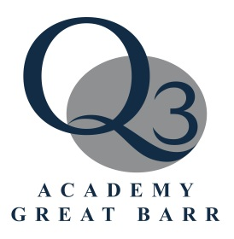
Q3 Academy
Please attach photo here
(external applicants only)
Great Barr

Application for Entry
to Sixth Form
September 2019

First name(s) :

Surname:

Address:
Post Code:

Home telephone number:

Mobile telephone number:

Date of birth:

Your email address:

Your present school :

School telephone number:

Siblings who attend/ed Q3 Academy Great Barr, include their current year group or leaving date:

Subjects to be studied at A-Level (in your preferred order):

Full GCSE/s  taken/to be taken | Exam Board | Date |  | Mock Result | Predicted Grade | Grade Achieved
 |  |  |  | FOR COMPLETION BY YOUR SCHOOL
English Language
Mathematics

Please note that all students are required to achieve a minimum of a grade 5 in
English Language and Mathematics, along with subject specific requirements.

Please note that we can only process applications that include all of the following:
- Your predicted grades;
- Reference from your school;
- Your attendance record for the current academic year.
School reference in support:

Please also provide an attendance report for the current academic year.

Referee’s Name:

Please ask your school office to stamp here
(external applicants only)

Referee’s Signature:

Date:

Applicant’s Signature Parent/Carer’s Signature Date

Please return by Friday 15th February 2019 to:

Mrs L Devane
Sixth Form Administrator
Q3 Academy
Wilderness Lane
Birmingham
B43 7SD

or send by e-mail to: 6thform@q3academy.org.uk.

External Applicants only:

Student ULN (available from your current school)

