LE MONDE ET MOI
YEAR 7

Name: ………………………………………………….
Class: …………………………………………………..
Teacher:……………………………………..........

LEARNING KEY QUESTIONS
Key Learning Points | WT | E | AE
How much French do you already know?
How do you greet others in French?
Can you say where you live?
Can you use prepositions with countries?
Can you say your nationality?
Which languages do you speak?
How do you say when your birthday is in French?
What do you look like?
Can you describe another person?
What are your favourite belongings?
Can you ask questions using correct intonation?
Where else speaks French?

Year 7 French knowledge Organiser: Term 1: Personal information, Physical appearance, Favourite objects

Key ideas
1 | Je m’appelle Lara.
2 | J’habite en Irlande.
3 | Je suis irlandiase.
4 | Je parle irlandais.
5 | J’ai douze ans.
6 | Mon anniversaire c’est le trois septembre.
7 | J’ai les yeux bleus.
8 | J’ai les cheveux blonds et longs.
9 | Voici ma copine Caroline.
10 | Elle a les yeux verts.
11 | Elle a les cheveux roux, longs et raides.
12 | Je n’ai pas de cheveux.
13 | Elle n’a pas de cheveux.
14 | Voici mon objet préféré.
15 | Il est en metal.
16 | Il est assez petit.
17 | Il est rond.
Key phrases

- Le monde et moi
- Quelle est la date?
- Mon autoportrait
- Mon objet préféré
- Le monde francophone

Key vocabulary

Bonjour | Good morning
Salut! | Hi
Au revoir! | Good bye!
Comment t’appelles-tu? | What is your name?
Je m’appelle… | My name is….
Où habites-tu? | Where do you live?
J’habite en/au… | I live in…
L’ Angleterre | England

Les verbes Les adjectifs

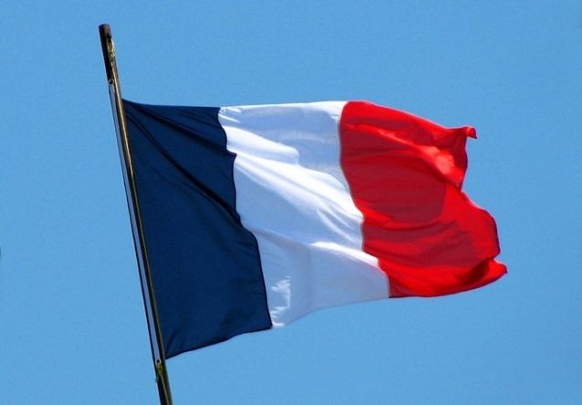
Avoir | To have
Être | To be
S’appeler | To be called
Parler | To speak/talk
Habiter | To live
préférer | To prefer
Bleu | Blue
Gris | Grey
Marron | Brown
Roux | Ginger
noisette | Hazel

Key questions
Anglais | Français
How much French do you already know? | Que connais-tu en français?
How do you greet others in French? | Comment dire bonjour?
Can you say where you live? | Où habites-tu?
Can you use prepositions with countries? | Quelles prepositions avec les pays?
Can you say your nationality? | Quelle est ta nationalité?
Can you say which languages you speak | Quelles langues parles-tu?
How do you say when your birthday is in French? | Quelle est la date de ton anniversaire?
What do you look like? | Comment es-tu?
Can you describe another person? | Décris une autre personne.
What are your favourite belongings? | Quel est ton objet préféré
Can you ask questions using correct intonation? | Comment poser des questions avec la bonne intonation?
Where else speaks French? | Où parle t-on francais dans le monde?

Useful grammatical structures Tricky pronunciations
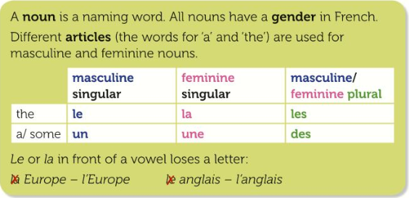

mi-long | La Belgique
mi-court | Le pays de Galles
Allemagne | Je n’ai pas de cheveux
Natté | Une collection de BD
Raides | Une console de jeux vidéo
J’habite | dix-sept

Tenses
Infinitives | Present | Imperfect | Past tense
Avoir | J’ai, tu as, il/elle a | J’avais, tu avais, il /elle avait | J’ai eu, tu as eu, il a eu
Etre | Je suis, tu es, il/elle est | J’étais, tu étais, il/elle était
S’appeller | Je m’appelle, tu t’apelles, il/elle s’appelle | Je m’appellais, tu t’appellais, il/elle s’appellait | Je me suis appelé(e), tu t’es appelé(e) il s’est appelé, elle s’est appelée
Préférer | Je préfère, tu préfères, il/elle préfère | Je préferais, tu préferais, il/elle préferais, | J’ai préfèré, tu as préfèré, il /elle a préfèré

Tricky spellings
Préféré | Ving et un
Velours | Vingt-deux
Quatre | Vingt-trois
Treize | Vingt-quatre
Quatorze | Vingt-cinq
Seize | Vingt-six

Strategies

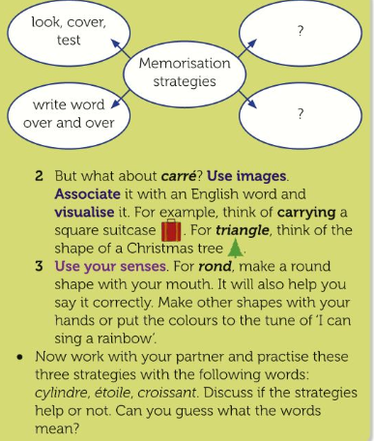

La date …………….……………………………………………..

Introduction: Tout sur moi
Traduisez le titre en anglais : …………………………………………………
TBAT greet in French
TBAT introduce yourself, say where you live, use prepositions with countries, nationality and languages you speak.

Les mots clés
Bonjour = hello Comme ci comme ça = I’m ok
Au revoir = good bye Merci = thank-you
Ça va ? = how are you ? S’il vous plait = please
Ça va bien = I am well Comment t’appelles-tu ? = what is your name? Ça va mal = I am not well Je m’appelle… = my name is…

Do now: Qu’est-ce qu’il y a sur la photo ? Write four simple words about what you can see.
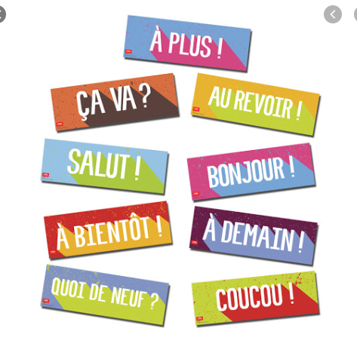

1. ……………………………………………………………………..............................................………………
2. ………………………………………..............................................……………………………………………
3. …………..............................................…………………………………………………………………….......
4. .............................................................................................................................................

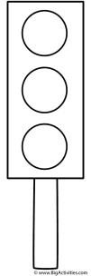
How to greet in French?
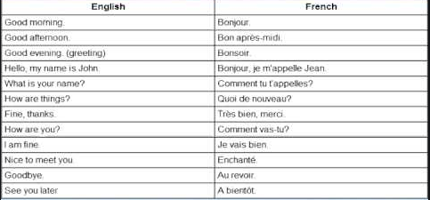

Practice: démêlez les mots( Unjumble the words to get them in French)
ua rirveo = va ca ? =
i’sl osuv ipalt = va ca lma = jnbooru =
va ca iebn =
Ej a‘mpelepls =
icrem =
momce ic momce aç = mmocnte ut a’tpelpels ? =

Progress check: How do you greet others in French ? Write 3 details below:
1----------------------------------------------------------------------------------------------------
2----------------------------------------------------------------------------------------------------
3----------------------------------------------------------------------------------------------------

How to say where you live and nationality?

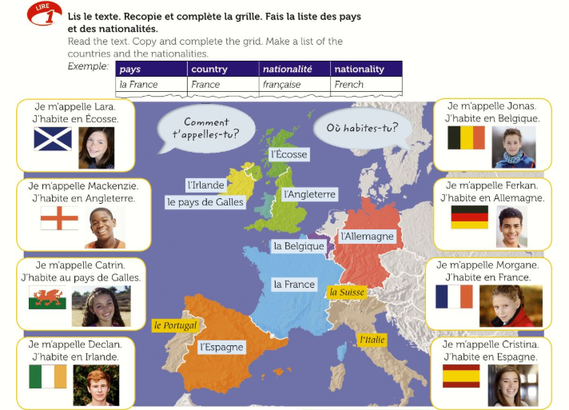

Pays | Country | Nationalité | Nationality
1-
2-
3-
4-
5-
6-
7-
8-
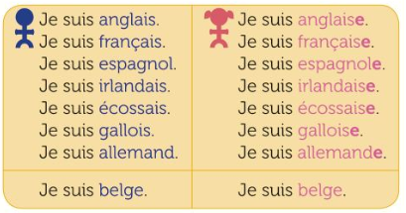
Les nationalités: To form the nationality, use this box. Example: Je suis français.
A girl would say: je suis française.

Languages you speak
Prepositions with countries

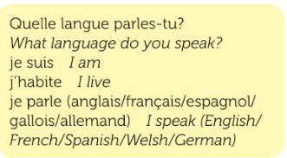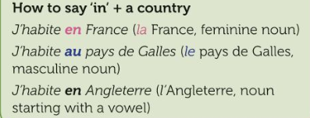

Practice:

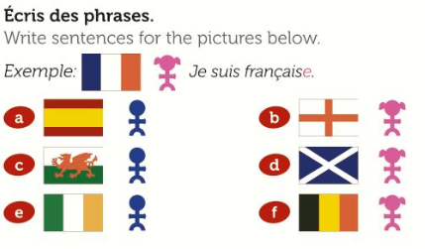
------------------------------------------------------------------------------------------------------------------------------------------------------------------------------------------------------------------------------------------------------------------------------------------------------------------------------------------------------------------------------------------------------------------------------------------------------------------------------------------------------------------------------------------------------------------------------------------------------------------------------------------------------------------------------------------------
------------------------------------------------------------------------------------------------------------------------------------------------------------------------------------------------------------------------------------------------------------------------------------------------------------------------------------------------
--------------------------------------------------------------------------------------------------------------------------------------------------------------------------------------------------------------------------------------------------------------------------------------------------------------------------------------------
La date …………….……………………………………………..

1.2 Quelle est la date de ton anniversaire ?
Traduisez le titre en anglais : …………………………………………………….
TBAT count up to 31 in French (-)
TBAT the months of the year in French (=) TBAT say dates and when your birthday is (+)
Les mots clés
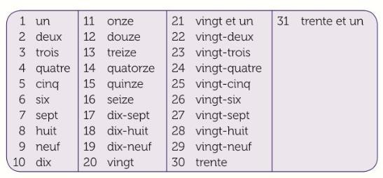

Do now: Qu’est-ce qu’il y a sur la photo ? Write four simple sentences in French about what you can see on the picture

I do: Sur la photo, il y a un chien. ( On the photo, there is a dog)
1. ……………………………………………………………………..............................................………………………………………………………………………………………………….…
2. ………………………………………..............................................…………………………………………………………………………………………………………………………….……
3. …………..............................................…………………………………………………………………………………………………………………………………………………
4. ..........................................................................................................................................................................................

Present:

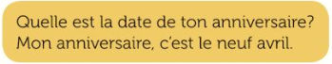
Practice: Traduisez en français. (Translate into French)
When is your birthday ? = ……………………………………………………………………………………………………….

My birthday is ………………. = …………………………………………………………………………………………………….

Challenge: Write out all of the months in the correct order in French using the jumble below
(remember, French months do not have a capital letter)

maijanviermarsjuinseptembredécembreaoûtfévrieravriljuilletoctobrenovembre

………………………………………………………………………………………………………………………………………

Quelle est la date de ton anniversaire?
I do: 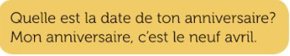
How did I do it?
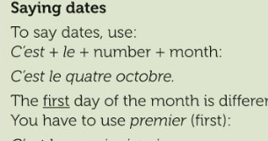
Your turn: How would you say these dates in French?
- 03/09…………………………………………………………………………………………………………
- 18/04…………………………………………………………………………………………………………
- 21/12----------------------------------------------------------------------------------------------------------------------------
- 06/06……………………………………………………………………………………………………………

You do: Lisez: Read the 3 descriptions and fill in the boxes below.
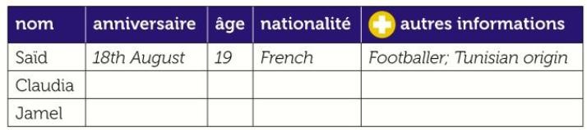
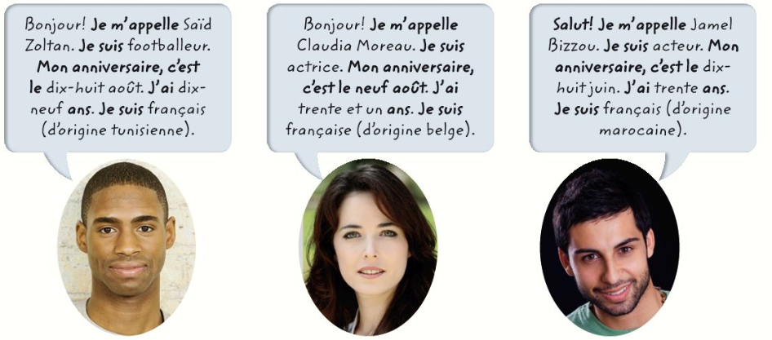

Challenge: How do you say when your own birthday is in French?
- ……………………………………………………………………..............................................…………………………………
…………………………………..............................................……………………………………………………………………..

Extended Writing: Use Said’s description to make your own one

……………………………………………………………………..............................................…………………………………
…………………………………..............................................……………………………………………………………………..
............................................……………………………………………………………………...........................................
...……………………………………………………………………..............................................………………………………
……………………………………..............................................…………………………………………………………………
….................................……………………………………………………………………...............................................

1.3 De quelle couleur sont tes yeux et cheveux ?
Traduisez le titre en anglais : …………………………………………………….
TBAT say I am and I have in French (-)
TBAT describe your eye colour in French (=)
TBAT describe your hair and eye colour in French (+)
Les mots clés
Je suis = I am Les yeux = eyes Les cheveux = hair
J’ai = I have Bleus = blue Bruns = brunette
Verts = green Blonds = blond
Marron = brown Roux = ginger
Do now:.Find these colours in French and write them in the box

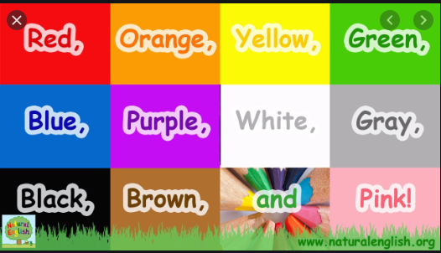
12
10
7
11
9
5
6
2
3
4
8
1
1-
2-
3-
4-
5-
6-
7-
8-
9-
10-
11-
12-

Present:

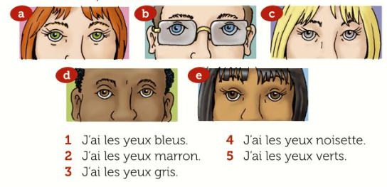
Match the pictures with the right sentence
1-
2-
3-
4-
5-

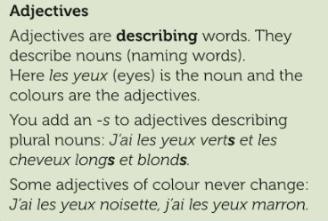

What is different about the position of adjectives (describing words) in French?
……………………………………………………………………..............................................…………………………………

Translate the sentences under each picture:
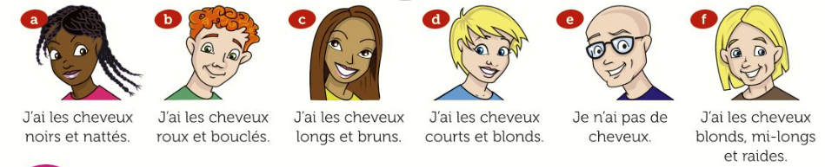
a……………………………………………………………………..............................................…………………………………
b…………………………………..............................................……………………………………………………………………..
c............................................……………………………………………………………………...........................................
d……………………………………………………………………..............................................…………………………………
e…………………………………..............................................……………………………………………………………………..
f............................................……………………………………………………………………...........................................

Progress Check
Lisez: Write the correct letter that matches the picture with the texts below.
1.
2.
3.
4.
5.

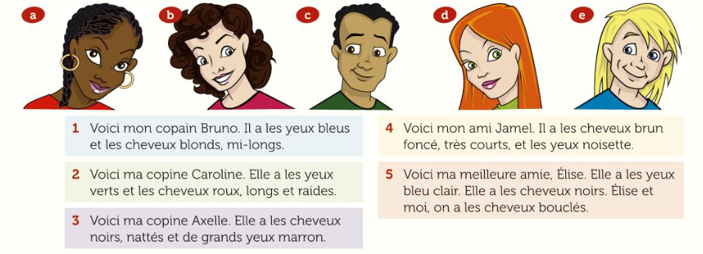

Produce:

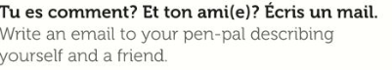

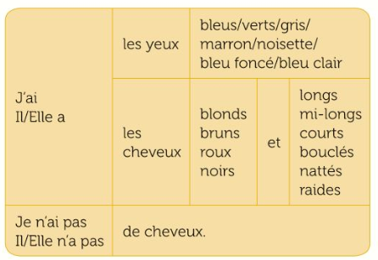

…………………………………………………………………..............................................………………..………………………
………………………………..............................................………………………………………………….…………………….....
.........................................……………………………………………………………………....................................................
………………………………………………………………………………………………………………………………………………….

Plenary: How do you describe your hair and eye colour in French?

…………………………………………………………………..............................................………………..………………………
………………………………..............................................………………………………………………….…………………….....
.........................................……………………………………………………………………....................................................
………………………………………………………………………………………………………………………………………………….

La date …………….……………………………………………..

1.4 Quel est ton objet préféré ?
Traduisez le titre en anglais : …………………………………………………….
TBAT say what objects you have (-) TBAT use adjectives (=)
TBAT use connectives (+)
Les mots clés
J’ai = i have Je préfère = I prefer
Mon objet préféré= my favourite object C’est / il est = it is
Et = and Aussi = also Mais = but

Do now: Qu’est-ce qu’il y a sur la photo ? Write 2 sentences in French about this picture

1. ……………………………………………………………………..............................................………………
2. ………………………………………..............................................……………………………………………

Present: Find these words in French
A teddy =…………………………………………………………………………..
A tablet =…………………………………………………………………………..
A console = …………………………………………………………………………..
A phone = …………………………………………………………………………..
A toy car = …………………………………………………………………………..
A comic book collection = …………………………………………………………………………..
Practice: Complete the table with words from the list in the previous activity. 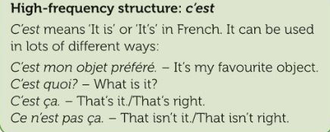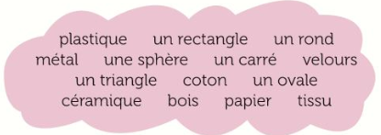
Matière | Forme
C’est en plastique | C’est un rectangle

Challenge: Draw a toy and describe it saying its colour, shape and what is made of

…………………………………………………………………..............................................………………..………………………
………………………………..............................................………………………………………………….…………………….....
.........................................……………………………………………………………………....................................................
………………………………………………………………………………………………………………………………………………….

Progress Check Lisez: read the descriptions (1-6) and write down the correct object.
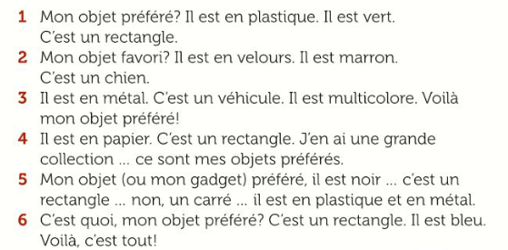

1. …………………………………………. 4. ………………………………………….
2. …………………………………………. 5. ………………………………………….
3. …………………………………………. 6. ………………………………………….

Produce: Read Bastien’s email and write a reply

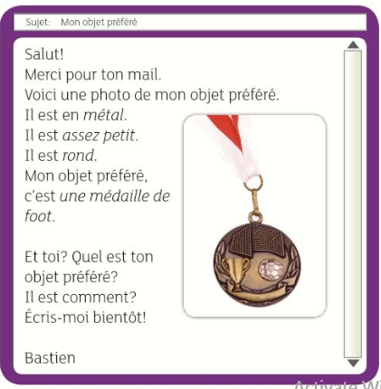
…………………………………………………………………..............................................……………………………………
………………………………..............................................…………………………………………………………………….....
.........................................……………………………………………………………………..............................................
………………………………………………………………………………………………………………………………………………….
…………………………………………………………………..............................................……………………………………
………………………………..............................................…………………………………………………………………….....
.........................................……………………………………………………………………..............................................
………………………………………………………………………………………………………………………………………………….

Asking questions
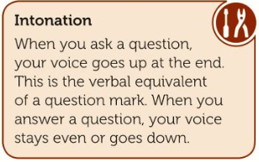

1.5 French speaking parts of the world
Traduisez le titre en anglais : …………………………………………………….
TBAT name French speaking parts of the world(-)
TBAT use prepositions with countries (=)
Les mots clés
J’ai = i have Je préfère = I prefer
Mon objet préféré= my favourite object C’est / il est = it is
Et = and Aussi = also Mais = but

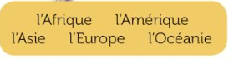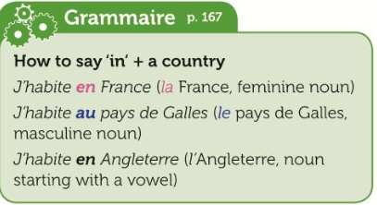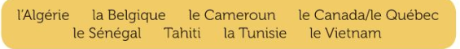
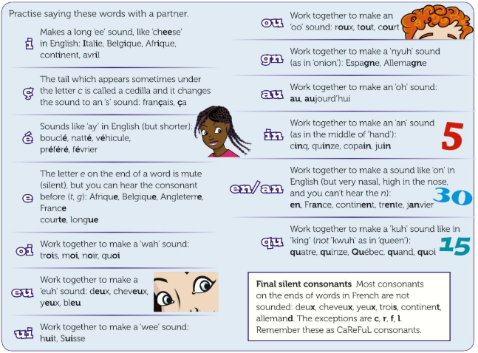

Produce: MILESTONE ASSESSMENT
Exam style question
Checklist:

- Check your spellings.
- Check that you have used articles
le/la/les or un/une before a noun.
- Check that you have given an
opinion.

Tu écris un blog sur vous. Mentionne :
  - Comment tu t’appelles ?;
  - Quelle est la date de ton anniversaire ?;
  - Décris tes yeux et cheveux;
  - Quel est ton objet préféré ? Pourquoi ?

Écris environ 40 mots en français. [16 marks]
……………………………………………………………………..............................................…………………………………
…………………………………..............................................……………………………………………………………………..
............................................……………………………………………………………………............................................
...……………………………………………………………………..............................................…………………………….…
……………………………………..............................................………………………………………………………………….

