Art and Design
Year 8
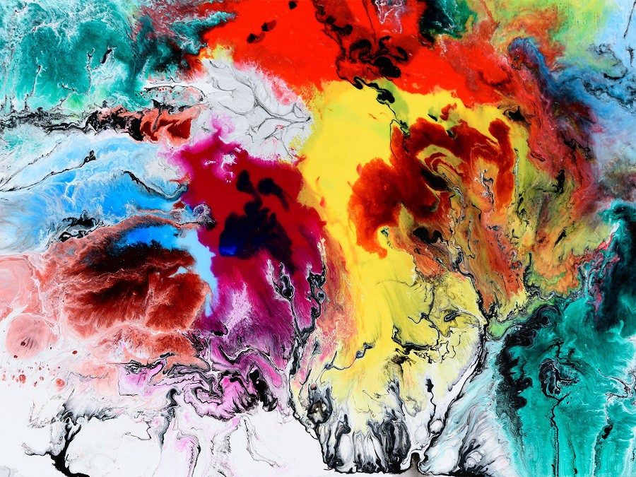

What are we going to be looking at and why?
Big Picture Question Sheet Year 8
Experimentation with materials and techniques - Experimentation is vital in Art as it allows you to build your skills in using a wide range of different materials and techniques. You going to used recycled and found materials to produce work of a new purpose, inspired by artists.
Pop Art - It is important that you learn about a variety of different art movements and how to replicate different art styles within your work. This broadens your knowledge of artwork from different cultures and gives you the opportunity to improve your observational drawing skills.
Perspective – Learning about perspective will improve the accuracy and neatness of your drawings and give you a deeper understanding of scale and proportion.

Key Learning Question | Answer
What does the term ‘recycle’ mean?
What key features should be included in an accurate observational drawing?
Why do artists create new work out of recycled and found materials?
Why is experimentation important in Art?
What are some of the features of the Pop Art style?
How does the use of a grid help you to accurately change the scale of an image?
How can you create art work in the Pop Art style?
Name three materials you have used over the past few weeks.
Name an artist we have looked in art?
Why is it important to learn about perspective? | Key Skills  - Drawing skills  - Painting skills  - Experimenting with a range of materials and surfaces  - Artist research  - Literacy: effective use of key words in Art  - Observational skills  - Knowledge and understanding surrounding artists and their work
Key words
- Line
- Tone
- Shape
- Shading
- 3D
- Form

- Mark-making
- Culture
- Painting
- Pop Art
- Photoshop
- Accuracy
- Abstract
- Observation
- Inspiration
- Experimentation
- Artist

Topic 1: Experimentation with materials
In this topic you are going to look at a variety of new techniques and materials, experimenting with different ways of working and producing artworks
You are also going to look at recycling and how artists create work from discarded materials that once had another purpose. This includes anything from old plastic toys and vehicle tires to scraps of cloth and building supplies. Artists who make recycled art take those materials and make them into something new.
Expectations
Learning question | Working towards | Expected | Above expected
What does the term ‘recycle’ mean? | I understand what ‘recycling’ means. I create work from recycled materials. | I understand what ‘recycling’ means and how artists repurpose materials within their work. I am inspired by artists to create my own recycled artworks | I understand what ‘recycling’ means and how artists repurpose materials within their own work. I am inspired by artists to create my own recycled artworks. I understand the importance of recycling and the environmental impact.
What key features should be included in an accurate observational drawing? | I understand how line, tone and shading are important in creating an accurate observational drawing. | I understand how line, tone and shading are important in creating an accurate observational drawing and apply this successfully. | I understand how line, tone and shading are important in creating an accurate observational drawing. I can accurately produce a realistic observation drawing.
Why do artists create new work out of recycled and found materials? | I know the names of artists which recycle and understand what they do | I can discuss the work of recycling artists and draw inspiration from them in my own work. | I can confidently discuss and identify features of artist’s work. I can work in the style of artists, drawing inspiration from recycled art.

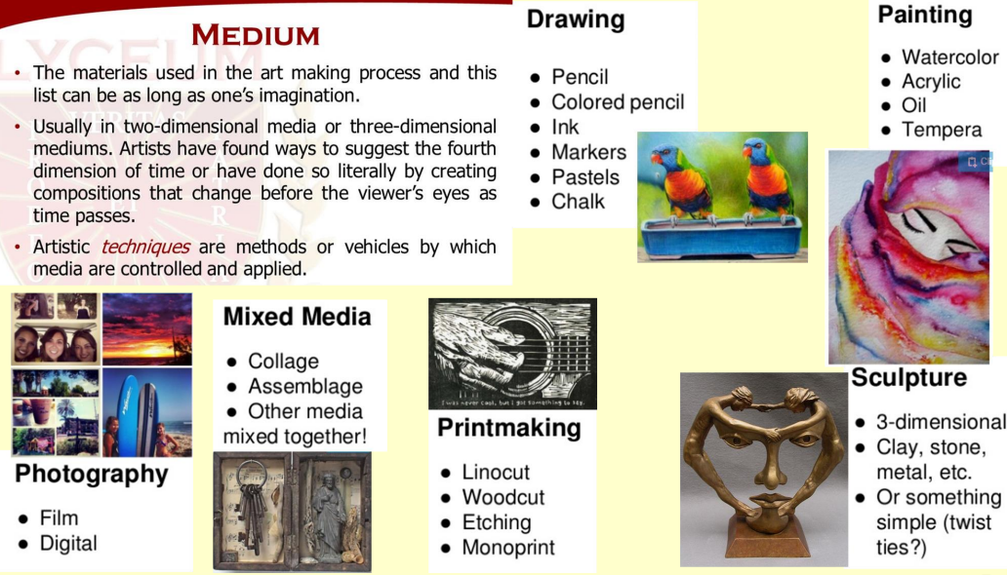
Art and Design Knowledge Organiser: Experimentation
Experimentation: Research
Question | Answer | Give more detail to the answer
What does ‘recycle’ mean?
Why is it important to recycle?
Name three artists who recycle and what they do?
What materials have you seen artists recycle to create new work?

LINE AND TONE
Experimentation: Observational drawing
You are to create a detailed observational drawing of a can. You are to do this in pencil and make sure you use tone to show the light and dark areas, highlights and shadows.
Experimentation: Contextual studies
What materials does Jennifer Collier use in her work?
__________________________________________________________________________________________
Why do you think she uses these materials?
_________________________________________________________________________________________________________________________________________________
Topic 2: Pop Art
Pop Art is an art movement that began in England in the 1950s and made its way to the United States during the 1960s.
Pop artists focused attention upon familiar images of popular culture such as comic strips, magasine advertisements, and food products. They often took inspiration from Pop music, Movies and the fashion industry.
Artists included; Roy Lichtenstein, Andy Warhol, Jim Dine, Claus Oldenburg, Jasper Johns

Expectations
Learning question | Working towards | Expected | Above expected
What are some of the features of the Pop Art style? | I can identify the features of Pop Art. | I can identify and discuss the features of Pop Art. | I can confidently discuss the features and characteristics of Pop Art.
How does the use of a grid method help you to accurately change the scale of an image? | I know to use the grid method to draw my image in the correct place. | I know to use the grid method to draw my image understanding how it helps me get the correct size, placement and proportion. | I can confidently use the grid method to draw my image understanding how it helps me get the correct size, placement and proportion.
How can you create art work in the Pop Art style? | I can understand the key features of pop art and create work of a similar style. | I can confidently understand the key features of pop art and create work of a similar style. | I can confidently understand the key features of pop art and create unique and accurate work of a similar style.

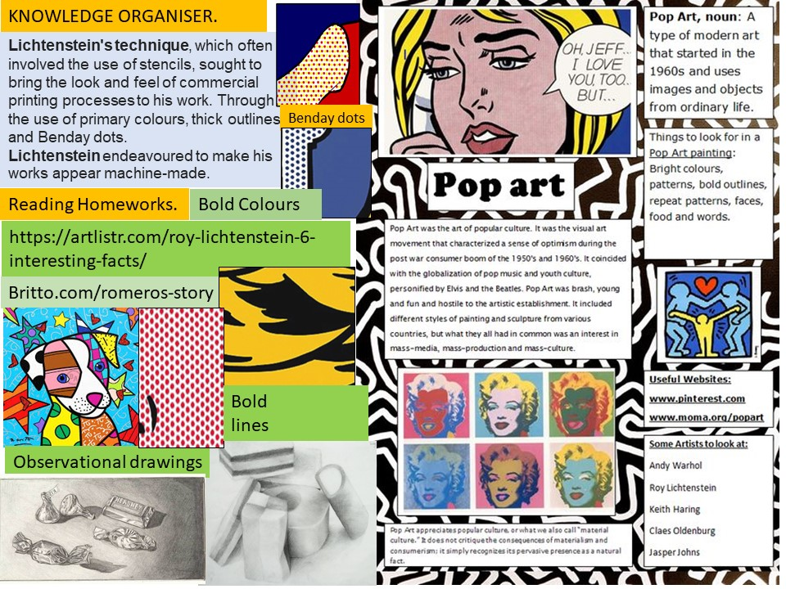
Art and Design Knowledge Organiser: Pop Art

Pop Art: Roy Lichtenstein

Roy Lichtenstein (1923 - 1997)
TASK: Create a drawing that combines/contains at least three of these five images. Draw in pencil first, then add bold and bright colours.
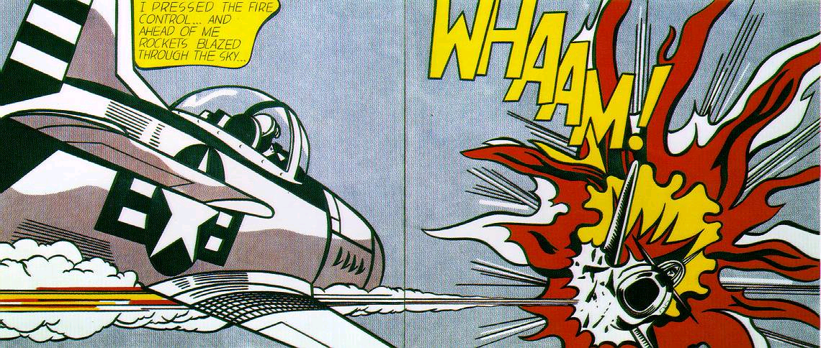
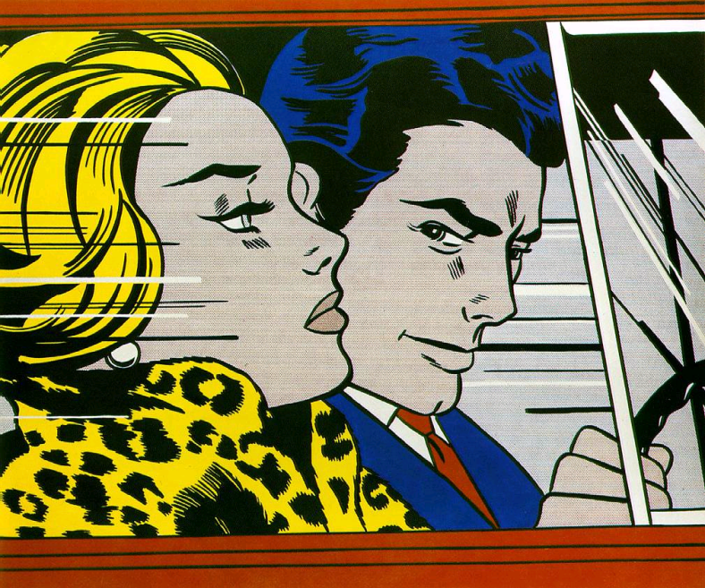
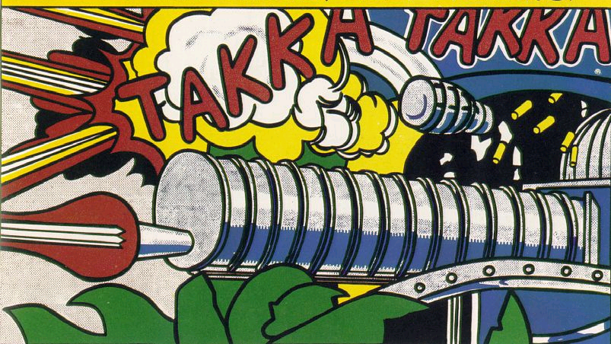
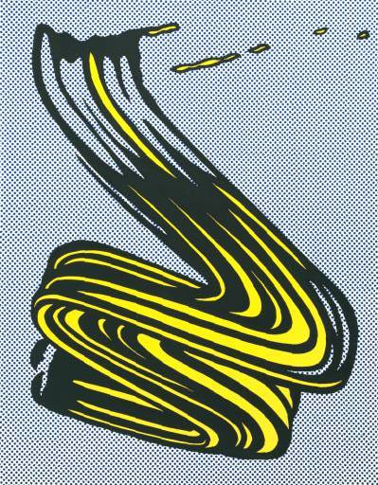

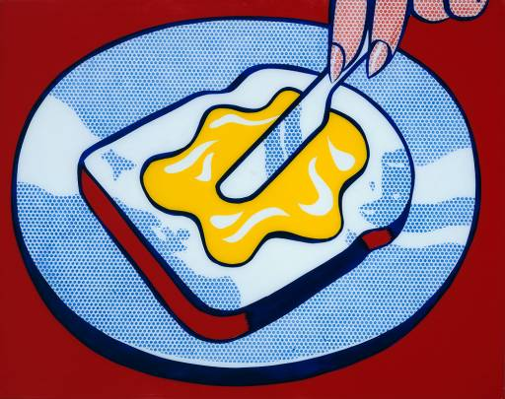
Pop Art: Contextual studies
Pop Art: Research

Pop Art: Artist research
Topic 3: Perspective

Perspective is how we look at something and how our eyes display the object to a vanishing point.
Learning about perspective will improve the accuracy and neatness of your drawings and give you a deeper understanding of scale and proportion.

EXPECTATIONS
Learning question | Working towards | Expected | Above expected
Why is it important to learn about perspective? | I understand what perspective is and can identify the different types of perspective. | I understand what perspective is and can identify the different types of perspective. I know how to adjust size and scale to make an image appear 3dimensional. | I understand what perspective is and can identify the different types of perspective. I am confident in adjusting size and scale to make an image appear 3dimensional.
What is one point perspective? | I can recognise one point perspective and its features. | I can recognise one-point perspective and its features. I can use this knowledge to draw scenes using one point perspective. | I can confidently recognise one-point perspective and its features. I can use this knowledge to draw scenes using one-point perspective. I use tone and shading to make my work appear more realistic.
What is two point perspective? | I can recognise two point perspective and its features. | I can recognise one-point perspective and its features. I can use this knowledge to draw scenes using two point perspective. | I can confidently recognise two-point perspective and its features. I can use this knowledge to draw scenes using one-point perspective. I use tone and shading to make my work appear more realistic.

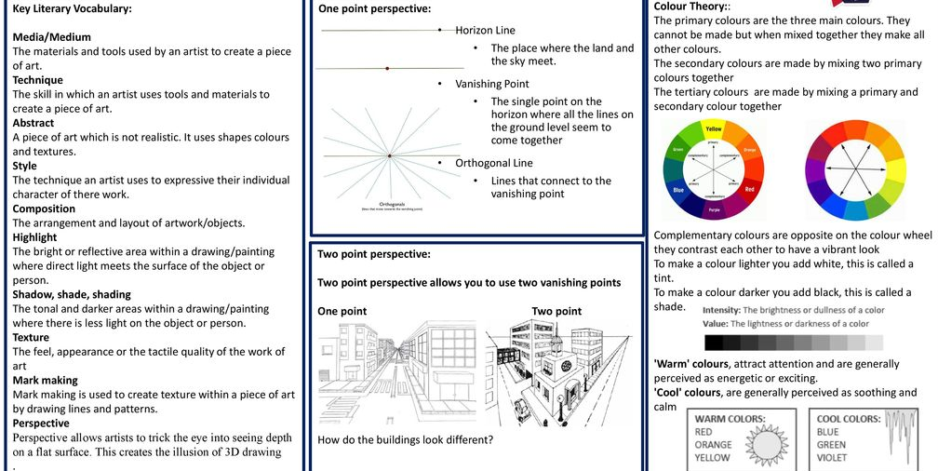
Art and Design Knowledge Organiser: Perspective
Perspective: One-point perspective
What is one-point perspective?

What is a vanishing point?

What is a horizon line?
Perspective: Two-point perspective
Perspective: Two-point perspective
Perspective: Two-point perspective

