Date (See Whiteboard)
How did the settling of America change what was there?
Do Now:
Give five reasons that for a country wanting to have a colony
Class reading
(Pre read) Your teacher will discuss key vocabulary with you (in bold)
Read through the America text as a class.
Task 1 (paired task)
In your exercise book make a list of all the changes that happened when the British colonised North America and the Caribbean.
Task 2 (individual task) In your exercise books, answer the questions at the bottom of the text. Answer using full sentences.
Task 3 (individual task)
In your exercise book, draw 3 images which show the changes that happened in North America and the Caribbean because of British colonisation.
Draw these images in a grid like this:

Task 4 (individual task)
In your exercise books, write a short summary paragraph which answers today’s learning question.

Date (see whiteboard)
How did the colonisation of America change what was there?
Do Now (individual task) – Knowledge Check – In exercise books answer these questions:
- What was England’s first successful colony in North America?
- What crop was successfully grown in this colony from 1617 onwards?
- What ship transported the first English settlers to New England in 1620?
- What was the biggest killer of Native American tribes living in North America?
- Which island was England’s first major sugar-producing colony?
Class Reading
The Native Americans living in the area where Jamestown was settled must have had mixed feelings about the arrival of the English in 1607. One of their first reactions was hostility based on their previous experience with Spanish explorers along their coastline. They attacked one of the ships before the English actually landed. Yet the Indians soon began to offer food and traditional Indian hospitality to the newcomers. At first, Powhatan, leader of a confederation of tribes around the Chesapeake Bay, hoped to absorb the newcomers through hospitality and his offerings of food. As the colonists searched for instant wealth, they neglected planting corn and other work necessary to make their colony self-sufficient. They therefore grew more and more dependent on the Indians for food.
As the colony's fortunes deteriorated during its first two years, Captain John Smith's leadership saved the colony. Part of this leadership involved exploring the area and establishing trade with local Indians. Unfortunately for the Indians, Smith believed that the English should treat Indians as the Spanish had: to compel them to "drudgery, work, and slavery," so English colonists could live "like Soldiers upon the fruit of their labor." Thus, when his negotiations with Indians for food occasionally failed, Smith took what he wanted by force.
By 1609, Powhatan realized that the English intended to stay. Moreover, he was disappointed that the English did not return his hospitality nor would they marry Indian women. He knew that the English "invade my people, possess my country." Indians thus began attacking settlers, killing their livestock, and burning such crops as they planted. All the while, Powhatan claimed he simply could not control the young men who were committing these acts without his knowledge or permission.
Expanding English settlements meant more encroachment on Native American lands and somewhat greater contact with Indians. It also left settlers more vulnerable to Indian attack. By this time, the Indians fully realized what continued English presence in Virginia meant--more plantations, the felling of more forests, the killing of more game--in sum, a greater threat to their way of life.
Source 1 - Chief Powhatan to John Smith:
Your coming is not for trade, but to invade my people and possess my country…Having seen the death of all my people three times… I know the difference of peace and were better than any other Country. [If he fought the English, Powhatan predicted], he would be so haunted by Smith that he can neither rest eat nor sleep, but his tired men must watch, and if a twig but break, every one cry, there comes Captain John Smith; then he must fly he know not whether, and thus with miserable fear end his miserable life.
Source 2 - How the Massacre of 1622 Was Good for the Plantation
On March 22, 1622, Powhatan Indians attacked and killed colonists in eastern Virginia. Known as the Jamestown Massacre, the bloodbath gave the English government an excuse to justify their efforts to attack Indians and confiscate their land..
Thus have you seen this massacre . . . where treachery and cruelty have done their worst to us, or rather they have done to themselves. These are the reasons why:
- Betrayal never goes unpunished
- The land we used before was their waste land which we purchased through trade. Now we may invade their country, seek to destroy those who sought to destroy us and we shall enjoy their cultivated land. Now their cleared grounds in all their villages shall be inhabited by us.
- Conquering them is easier than civilising them by fair means. They are a rude, barbarous and naked people. Victory against them may be gained in many ways such as burning their corn, destroying their boats and houses.
- The Indians, who before we treated like as friends, can now be used in servitude to perform inferior tasks such as digging in mines.
- Our colony will now be given more assistance from the King, as his royal favour has been extended to supply men and resources which will arrive in Virginia shortly.
Requests from the Iroquois Chiefs to the settlers 1684
Because rival tribes continued attacks on the Iroquois in Virginia (encouraged by the French who hoped to disrupt the English-Iroquois alliance), a meeting was arranged in Albany in 1684 with the Five Nations of the Iroquois and the governors of New York and Virginia.
“Your tribe is a great tribe and we are but a small People; but when the English came first to Manhatan, (New York) to Aragiske (Virginia) and to Yakokranagary (Maryland), they were then a small People, and we were great. Then, because we found you a good People, we treated you kindly, and gave you Land; we hope therefore, now that you are great, and we small, you will protect us from the French. If you do not, we shall lose all our Hunting and Beavers: The French will get all the Beavers. The Reason they are now angry with us is, because we carry our Beaver to you, our brethren.”
Task 1 (paired task) – Highlight examples in the text and sources to show the relationship between the colonists and Native Americans. Use one colour for positive, another for negative.
Task 2 (paired task) – Draw a graph in your exercise books, the X axis should show the dates of events, the Y axis should show positive relations at the top, and negative relations at the bottom. Add the events from the text onto this graph to show how the relationship between the English and the Native Americans changed over time.
Task 3 (individual task) – In your exercise books, write a short summary paragraph which answers today’s learning question.
Date (see whiteboard)
Why did American colonists change their minds on being in the British Empire?
Do Now
- Which European country first established colonies, such as Mexico, in the Americas?
- What are Britain’s colonies in America collectively called from 1732 onwards?
- What was the biggest killer of Native American tribes living in North America?
- Why did the Native Americans sometimes react negatively to English colonists?
- What were the first settlers in New England, known for their religious Puritanism, called?
Class Reading
(Pre read) Your teacher will discuss key vocabulary with you (in bold)
Read through American Revolution text as a class.
Task 1 (paired task)
Create a timeline which outlines the events leading up to the American War of Independence.
Task 2 (individual task)
In your exercise books, answer the questions at the bottom of the article in full sentences.
Task 3 (individual task)
Draw a graph in your exercise books, the X axis should show the dates of events, the Y axis should show positive relations at the top, and negative relations at the bottom. Add the events from your timeline to show how the relationship between the English and the American colonists changed over time.

Date (see whiteboard)
How did the Thirteen Colonies become the USA?
Do Now
- What controversial 1765 law taxed legal and other documents in the American colonies?
- What event in March 1770 turned many American colonists against the British Army?
- What phrase came to define the colonists’ objection to British rule?
- Parliament’s attempt to enforce the East India Company’s monopoly led to what event?
- Who was Britain’s king at the time of the American Revolution?
Class Reading
(Pre read) Your teacher will discuss key vocabulary with you (in bold)
Read through American War of Independence text as a class.
Task 1 (paired task)
Create a timeline which outlines the events of the American War of Independence.
Task 2 (individual task)
In your exercise books, answer the questions at the bottom of the text. Answer using full sentences.
Task 3 (paired task) – Read through some of these key parts of the American Constitution. For each bullet, write in your exercise books why you think each rule was chosen for the new American nation..
Congress can’t make any law that:
- Favors one religion over another religion, or no religion at all, or opposes any religion;
- Stops you from practicing your religion as you see fit;
- Keeps you from saying whatever you want, even if you are criticizing the President of the United States;
- Prevents newspapers, magazines, books, movies, radio, television or the internet from presenting any news, ideas, and opinions that they choose;
- Stops you from meeting peacefully for a demonstration or protest to ask the government to change something.
- Congress can’t stop people from having and carrying weapons.
- The government can’t take your house or your farm or anything that is yours, unless the government pays for it at a fair price.
Activity 4 (individual task)
In your exercise books, write a short summary answering today’s learning question.

Date (see whiteboard)
What changes were a result of the Transatlantic Slave Trade?
Do Now (individual task) – Knowledge Check – answer questions in your exercise books.
- What was England’s first successful colony in North America?
- Which island was England’s first major sugar-producing colony?
- What nickname was given to sugar in the British colonies?
- In what year was the American Declaration of Independence approved?
- What do you call a series of laws establishing how a nation’s political system functions?
Class Reading
(Pre read) Your teacher will discuss key vocabulary with you (in bold)
Read through Transatlantic Slave Trade text as a class.
Task 1 (individual task) – In your exercise books, answer the questions at the bottom of the text. Answer using full sentences.
Task 2 (paired task) – read through the three sources below and highlight examples of negative treatment of slaves.
“When we arrived at the castle, I saw [my kidnapper] take a gun, a piece of cloth, and some lead [to trade] for me... when a vessel arrived to conduct us away to the ships, there was nothing to be heard but the rattling of chains, smacking of whips, and the groans and cries of our fellow men… And when we found ourselves at last taken away, death was more preferable than life.”
—Ottobah Cugoano, Nigerian slave, 1787
"The closeness of the place, and the heat of the climate, added to the number in the ship, which was so crowded that each had scarcely room to turn himself, almost suffocated us. This produced copious perspirations, so that the air soon became unfit for [breathing], from a variety of loathsome smells, and brought on a sickness among the slaves, of which many died, thus falling victims to the [thoughtless greed], as I may call it, of their purchasers. This wretched situation was again aggravated by the galling of the chains, now become insupportable; and the filth of the necessary tubs (buckets of human waste), into which the children often fell, and were almost suffocated. The shrieks of the women, and the groans of the dying, rendered the whole a scene of horror almost inconceivable.”
—Olaudah Equiano, who was 11 years old when sold into slavery
"Exercise being deemed necessary for the preservation of their health they are sometimes obliged to dance when the weather will permit their coming on deck. If they go about it reluctantly or do not move with agility, they are flogged (whipped); a person standing by them all the time with a cat- o'- nine- tails in his hands for the purpose."
—Alexander Falconbridge, An Account of the Slave Trade on the Coast of Africa
Task 3 – Write a short paragraph answering today’s learning question. Use the text and the sources to help you. Write about how slavery changed the colonies, British trade and the lives of slaves.

Date (see whiteboard)
What changes were a result of the transatlantic slave trade?
Do Now (individual task) – highlight or ask five things about this picture (on sheet).
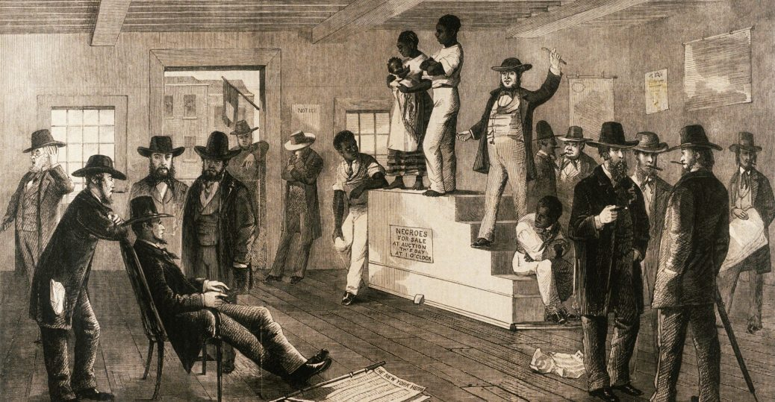
Class Reading
(Pre read) Your teacher will discuss key vocabulary with you (in bold)
Read through the Life as a slave text as a class.
Task 1 (individual task) In your exercise books, answer the questions at the bottom of the text. Answer using full sentences.
Task 2 (paired task) Draw a 9 cell (3x3) storyboard in your exercise books. Draw three images to show the arrival of slaves. Draw another three images to show the work that slaves carried out. Draw a final three images to show slave resistance.
Task 3 (individual task) Write a short summary paragraph which answers todays learning question. Write about the changes to the lives of enslaved people when they arrived in the Caribbean and Thirteen Colonies.

Date (see whiteboard)
How did attitudes towards the transatlantic slave trade change?
Do Now - (individual task) – Knowledge Check – answer questions in your exercise books.
- What tropical islands were the destination for most slaves traded by British merchants?
- What trade system imports and exports goods to and from three destinations?
- What term is often given to the sea journey undertaken by slave ships from West Africa?
- Which British port cities grew particularly wealthy from the slave trade?
- What were escaped slaves, who settled in the interior of Caribbean islands, called?
- Name the freed slave who moved to London and published his autobiography in 1789.
Class Reading
(Pre read) Your teacher will discuss key vocabulary with you (in bold)
Read through the text on Abolition as a class.
Task 1 (individual task) – In your exercise books, answer the questions at the bottom of the text. Answer using full sentences.
Task 2 (paired task) – find all the actions that abolitionists took to try to end the slave trade in the text.
Task 3 (individual task) copy the table below into your exercise books and complete using the actions you found from task 2.
What actions did abolitionists take? | What was it? | Why did this put pressure on Parliament to end slavery?

Task 4 (individual task) write a short summary paragraph which answers todays learning question. To answer you should comment on what the abolitionists wanted to achieve and how they tried to achieve this.

Date (see whiteboard)
How did attitudes towards the transatlantic slave trade change?
Do Now - (individual task) – Knowledge Check – answer questions in your exercise books.
- What term was given to someone who publicly campaigned to end slavery?
- Which leading campaigner helped form the Society for the Abolition of the Slave Trade in 1787?
- What term is given to an organised refusal to purchase a particular product?
- Who was the leading campaigner against the slave trade in the House of Commons?
- In what year did the British Parliament abolish the transatlantic slave trade?
- How many people signed the 1828 petition demanding the outright abolition of slavery?
- In what year did Parliament abolish slavery in the British Empire?
Task 1 – (paired task) look at this source and answer the questions below in your exercise books.
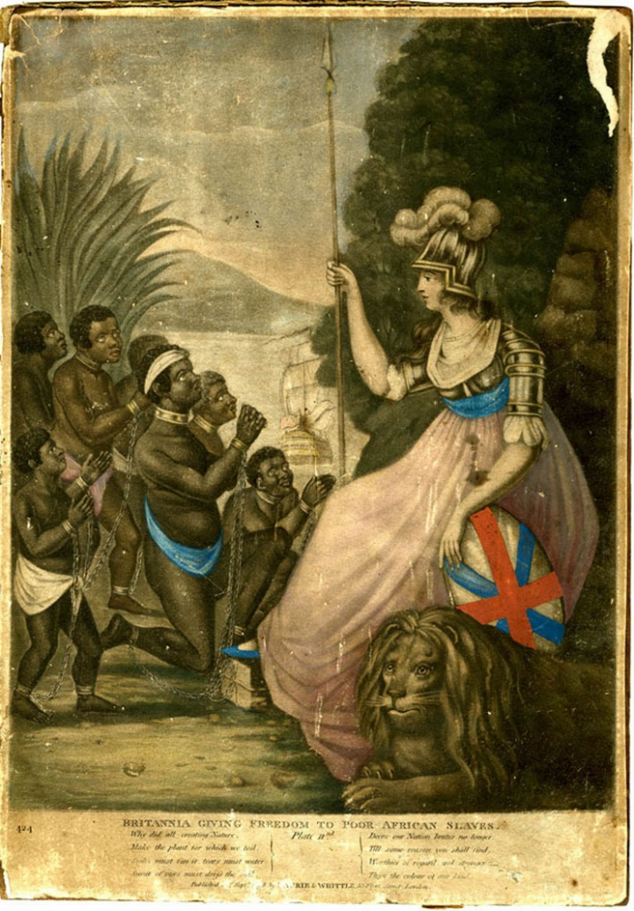
Britannia giving freedom to the poor African slaves made in the 18th Century by abolitionists.
- What evidence can you find from this image that the campaign to abolish the slave trade appealed to people's sympathy?
- What evidence can you find from this image that the campaign to abolish the slave trade appealed to people's sense of patriotism?
- How does the image suggest that despite their cause, abolitionists didn't necessarily view Africans on equal terms as white Europeans?

Class Reading Read through the extract from Mary Prince’s autobiography.
Mary Prince was born as a slave in Bermuda in 1788 and suffered several brutal slave owners. She eventually travelled to Britain with her ‘owners’ and gained her freedom, but only if she stayed in Britain. Her autobiography was published after the slave trade was banned in the British Empire, however before slavery itself was banned. This autobiography helped to remind people in Britain that although no slaves were being transported to the colonies, there were still thousands of enslaved people in the British Empire.
EXTRACT:
“Oh the horrors of slavery! - How the thought of it pains my heart! But the truth ought to be told of it; and what my eyes have seen I think it is my duty to relate; for few people in England know what slavery is. I have been a slave - I have felt what a slave feels, and I know what a slave knows; and I would have all the good people in England to know it too, that they break our chains, and set us free…I am often much vexed and I feel great sorrow when I hear some people in this country say, that the slaves do not need better usage, and do not want to be free. They believe the foreign people, who deceive them and say slaves are happy. I say, Not so. How can slaves be happy when they have the halter round their neck and the whip upon their back? And are disgraced and thought no more of than beasts? -and are separated from their mothers and husbands, and children and sisters, just as cattle are sold and separated?
Since I have been here I have often wondered how English people can go out into the West Indies and act in such a beastly manner. But when they go to the West Indies, they forget God and all feeling of shame, I think, since they can see and do such things. They tie up slaves like hogs - moor them up like cattle, and they whip them, so as hogs, or cattle, or horses never were flogged; - and yet they come home and say, and make some good people believe, that slaves don't want to get out of slavery. But it is not so. All slaves want to be free - to be free is very sweet. I have been a slave myself - I know what slaves feel - I can tell by myself what other slaves feel and by what they have told me. The man that says slaves be quite happy in slavery - that they don't want to be free - that man is either ignorant or a lying person. I never heard a slave say so.
Task 2 (paired task) Underline in the Mary Prince text any words or phrases which would be used to persuade people that the slave trade was wrong.
Task 3 (Individual Task) Imagine you are an abolitionist campaigning to bring about an end to slavery. Write a campaign speech to persuade people to support the abolition of slavery.
You might want to include:
- descriptions of the work that slaves perform,
- their work conditions and when they are transported
- other moral arguments that you have read about abolitionists using
- the actions people can take to try to stop slavery.
Use the poster from task 1, the extract from task 2 and also your work from previous lessons to help you.
Date (see whiteboard)
What changed in India whilst it was in the British Empire?
Do Now - (individual task) – Knowledge Check – answer questions in your exercise books.
- What are Britain’s colonies in America collectively called from 1732 onwards?
- Why did the Native Americans sometimes react negatively to English colonists?
- What term is often given to the sea journey undertaken by slave ships from West Africa?
- Who was Commander-in-chief of American forces during the War of Independence?
- What term was given to someone who publicly campaigned to end slavery?
Class Reading
(Pre read) Your teacher will discuss key vocabulary with you (in bold)
Read through the text on India as a class.
Task 1 (individual task) – In your exercise books, answer the questions at the bottom of the text. Answer using full sentences.
Task 2 – Label the three East India Company’s factories (read paragraph 3 in the text). Then shade in the territory that the East India Company ruled over by 1815 (read the last paragraph).
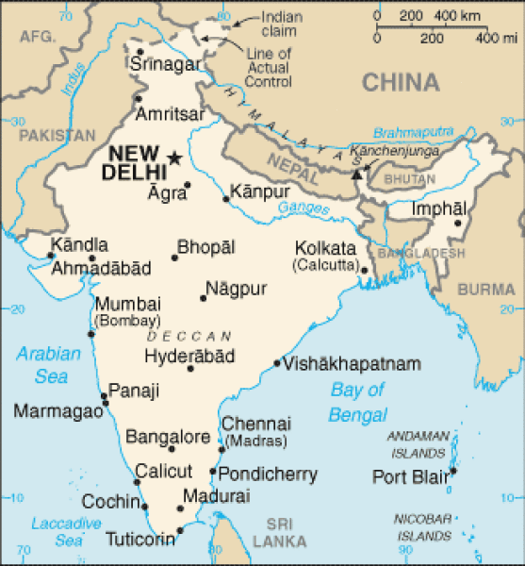

Task 3 (individual task) – copy this table into your exercise books. Complete the table showing the East India Company’s control.
 | Before Treaty of Allahabad | After Treaty of Allahabad
Who ruled Bengal?
Who collected Bengal’s tax?
Size of the East India Company Army
Land under British control
Population under British control
Amount of tax the British collected from India.

Task 4 (individual task) - Write a short summary paragraph which answers todays learning question. Write about the change in British influence over India as time went on and the reasons for these changes.

Date (see whiteboard)
What changed in India whilst it was in the British Empire?
Do Now - (individual task) – Knowledge Check – answer questions in your exercise books.
- Which imperial dynasty ruled in India from the 16th to the 19th century?
- What English company formed in 1600 was granted exclusive rights to trade with India?
- What was a trading post where merchants did business in foreign lands called?
- In which northeastern province of India did the British build their trading post Calcutta?
- Which British officer defeated Siraj ud-Daulah at the Battle of Plassey?
- What treaty granted Britain an Indian Province to rule for the first time?
Class Reading Read through the changes that happened in India as a class and discuss what they mean. Are these changes good? Are they short-term changes or long-term changes?
Task 1 (paired task) For each change that happened in India whilst it was part of the British Empire give it a value for how good a change it was for India (1=bad change 5=neutral 10=positive change) and also how long this change would last in India (1=short-term 5=neither 10=long-term).
Changes | How good a change was this? /10 | How long did this change last?  /10
- The first rail opened in 1853, between Bombay and Thane. The vast network of railways in India today, were built in the 19th century. The development of an efficient transportation system, helped not only the British government but also the Indians, who started to move from places to places. This helped bring unity among different parts of the country.
- India is a country of many languages. The British made English the compulsory language of education. This was to help raise Indian administrative staff to help run India. It helped Indians as they had a common language and through the education system helped to modernise India.
- The Indian legal system adopted many of the British ideas of liberty, democracy, equality and human rights. The British banned practises such as widows having to be burned with the corpse of her dead husband and child marriages.
- Cricket became the national sport of India. Suits, ties and trousers became the fashion of clothing in India.
- Agriculture was commercialised by the British. Tea, coffee, indigo, opium, cotton and sugarcane all were grown for profit. Before Indians had only grown the food they needed.
- India natural resources were used and the British profited directly from their export. Very little money went to Indian citizens.
- The British created the myth that Hindus and Muslims could not live together peacefully. This led to years of conflict which still rages today.
- The British treated Indians as inferior to themselves because of their race. Indians died in both famines and wars as a result.
- The Indian population had no decision making powers whatsoever during British rule.
- The British imposed high taxes upon Indian citizens which led to a decline in the handicraft industry.
- British rule protected India from invasion.
- The British introduced stable taxes and uniform tax rules. Before this Indian rulers made them up when they needed income

Task 2 (individual task) – Add the number of each change (1-12) onto this graph on this sheet.

Task 3 (individual task)
Write a paragraph which answers today’s learning question. Use the changes from task 1 and the graph from task 2 to help you.
Word Bank
Use these words to describe positive and negative changes: progressed, developed, cultivated, weakened, deteriorated, and declined.
Use these words to describe longevity of change: temporary, short-lived, brief, endured, lasted and continued.

Date (see whiteboard)
How did Britain’s Relationship with India Change?
Do Now - (individual task) – Knowledge Check – answer questions in your exercise books.
- What crop was successfully grown in Virginia from 1617 onwards?
- Which island was England’s first major sugar-producing colony?
- Parliament’s attempt to enforce the East India Company’s monopoly in America led to what event?
- In what year did Parliament abolish slavery in the British Empire?
- How many Indians were living under British rule by 1815?
- What treaty granted Britain an Indian Province to rule for the first time?
Class Reading
(Pre read) Your teacher will discuss key vocabulary with you (in bold)
Read through the text on the Indian Rebellion as a class.
Task 1 (individual task) In your exercise books, answer the questions at the bottom of the text. Answer using full sentences.
Task 2 (individual task)
Imagine you are an Indian Sepoy who is unsatisfied with the way that the East India Company has been running India. Write a letter to Lord Bentinck explaining:
- What the Sepoys are unhappy about
- What the aims of the rebellion are
Task 3 (paired task) – draw a two column table in your exercise books with one heading ‘before the Indian Rebellion’ and the other ‘after the Indian Rebellion’. Read through the text and add information about the organisation of British rule, attitudes towards Indian customs and the treatment of Indian people.
Task 4 (Individual Task) – Write a paragraph which answers today’s learning question.
Think about: how the British treated Indian people before the rebellion, how they treated the rebels during the rebellion and how they treated Indian people after the rebellion.
Word Bank
Use these words to describe positive and negative changes: progressed, developed, cultivated, weakened, deteriorated, and declined.
Use these words to describe longevity of change and continuity: temporary, short-lived, brief, endured, lasted and continued.

Date (see whiteboard)
How did India’s relationship with Britain Change?
Do Now - (individual task) – Knowledge Check – answer questions in your exercise books.
- What event in March 1770 turned many American colonists against the British Army?
- In what year was the American Declaration of Independence approved?
- What large colonial estates were used to grow crops such as coffee, sugar and tobacco?
- What name was given to the Indian soldiers serving in the British Indian Army?
- What term was used to describe British rule of India from 1858 to 1947?

Class Reading
(Pre read) Your teacher will discuss key vocabulary with you (in bold)
Read through the text on the decolonising India as a class.
Task 1 (individual task) In your exercise books, answer the questions at the bottom of the text. Answer using full sentences.
Task 2 (paired task) Using the dates and events from the text, create a timeline in your exercise books showing how India and Pakistan became independent nations.
Task 3 (individual task) In your exercise books, write an answer to today’s learning question. Your answer should cover information you have learned from the last four lessons on India.
Your answers should include information on:
- How and why India became a British colony
- The changes that happened in India when it was a British colony
- Opposition to India being a British colony
- How India and Pakistan became independent nations.
Remember to include: important dates, names of important people and important events.
Word Bank
Use these words to describe positive and negative changes: progressed, developed, cultivated, weakened, deteriorated, and declined.
Use these words to describe longevity of change and continuity: temporary, short-lived, brief, endured, lasted and continued.

Date (see whiteboard)

Date (see whiteboard)
How did the ‘Scramble for Africa’ change Africa?
Do Now - (individual task) – Knowledge Check – answer questions in your exercise books.
- What nickname was given to sugar in the British colonies?
- Which British port cities grew particularly wealthy from the slave trade?
- Name two minor forms of resistance in which slaves would engage?
- Which imperial dynasty ruled in India from the 16th to the 19th century?
- Who led the Indian National Congress to gain independence for India?
- Why did India and Pakistan become two separate countries when they became independent?
Class Reading
(Pre read) Your teacher will discuss key vocabulary with you (in bold)
Read through the text on the Scramble for Africa as a class.
Task 1 (individual task) In your exercise books, answer the questions at the bottom of the text. Answer using full sentences.
Task 2 (paired task) Look below at the map which shows the countries of Africa and which European powers they were colonies of. Read through the text and find the events when Britain gained colonies in Africa. For each event, draw an arrow on the map and write a short description of when and how that colony became part of the British Empire.
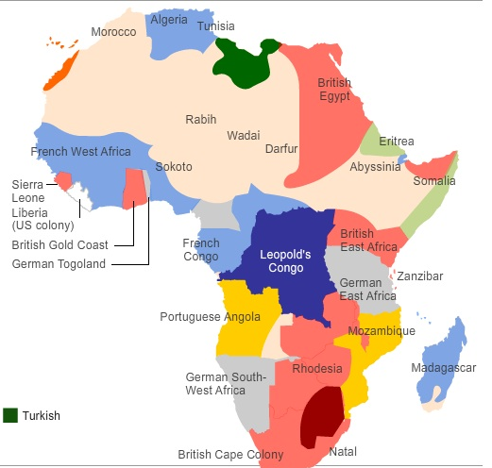

Task 3 (paired task) – Read through the reasons why the Scramble for Africa happened. Categorise them into Political. Economic and Social reasons.
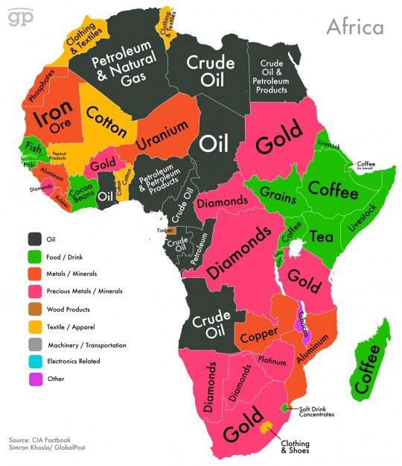
Europeans held the racist view that white people were superior to non-white peoples. Colonisation reinforced this idea.
Europeans believed that they would bring ‘civilisation’ to Africa through religion and rule.

After its victory in the Franco-Prussian War, Germany became much more powerful. France lost land to Germany so wanted to expand its territory further in West Africa.
Many Europeans had campaigned against the slave trade which saw an end to slavery in most European countries. Colonising African countries to make sure that slavery didn’t happen was a good excuse.
Europeans had more money because of the Industrial Revolution. They needed a new place to invest that money into.
Africans were cheap to employ as labourers.

Christian missionaries were already in Africa and had paved the way for colonisation to begin. They now demanded protection from their home countries.
The Suez Canal was constructed in Egypt which linked Europe to Asia by ship. Africa was now very important.
Nationalism was increasing in Europe, by having colonies countries were increasing their prestige.
Africa was made up of many smaller communities which had already been severely weakened by the slave trade.
Public opinion in Europe changed to show that Europeans wanted their countries to have large empires.

Task 4 – (individual task) – In your exercise books, write an answer to today’s learning question. Include which colonies became part of the British Empire, the events which led to them being colonies and the reasons why European powers wanted to gain African colonies.

Date (see whiteboard)
How did Britain govern the British colonies?
Do Now - (individual task) – Knowledge Check – answer questions in your exercise books.
- What proportion of African territory did European powers colonise from 1880 to 1900?
- What was this period of European colonisation known as?
- What was the name of one of the world’s first machine guns, used by British troops in this battle?
- What was discovered in this colony in 1866, attracting a flood of British settlers?
- Which businessman and politician in southern Africa became an icon of the British Empire?

Class Reading
(Pre read) Your teacher will discuss key vocabulary with you (in bold)
Read through the text on Ruling the Empire as a class.
Task 1 (individual task) In your exercise books, answer the questions at the bottom of the text. Answer using full sentences.
Task 2 – (paired task) In your exercise books copy the table below. Think back to the text you have read and also what you have studied on British colonies in America, the Caribbean, India, Africa and also involvement in the slave trade. Add in ways that Britain benefited from having the empire and also ways that colonies benefited from being in the Empire.
How did Britain benefit from the Empire? | How did the Empire benefit from Britain?

Task 3 – Read the text below. Write reasons for and against these statues being torn down.
In 2020 the Edward Colston statue in Bristol was torn down because of Colston’s connections with the slave trade. There are also calls for Rhodes statue to be removed from Oxford because of his connection to the exploitation of Africa.
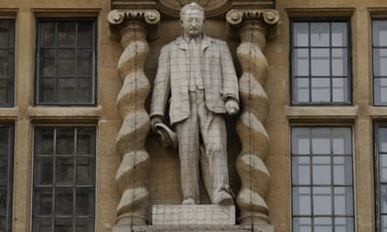
This photo shows the statue of Cecil Rhodes on the building of Baliol College, University of Oxford. Cecil Rhodes colonised what is now Zimbabwe but at the time was called Rhodesia after himself. In the late 19th century, Rhodes exploited Rhodesia for its diamonds and gold and believed that the British were superior to other people from other countries. Rhodes gave lots of money to Oxford University and established the Rhodes scholarship which allows 100 international students each year to study at the university for free to this day. This is why the statue is in Oxford.
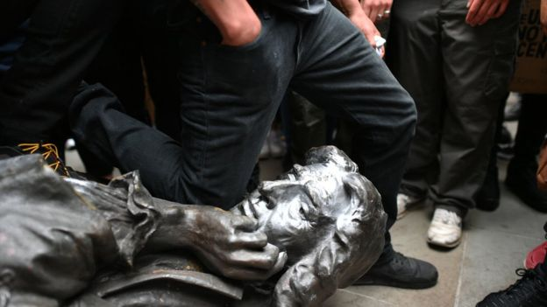
This photo shows the statue of Edward Colston, a slave trader from Bristol. In the early 17th century, Colston was a member of the Royal African Company which traded goods for African slaves from West Africa to sell in the Caribbean. Colston gave founded alms houses (institutions to help the poor) founded two hospitals and several schools. This is why his statue was in Bristol.

